From Data to Market Value in Virtual Power Plants: A Structured Evidence Review of Decision Integrity, Uncertainty, and Electricity–Carbon Market Integration

Abstract
Virtual power plants (VPPs) turn dispersed flexibility into market value through steps usually studied one at a time: measurement, forecasting, uncertainty modeling, optimization, bidding, clearing, dispatch, deviation, settlement. This review treats that chain as the unit of analysis. We ask: when a VPP study reports a better forecast, a richer optimization model, or a higher simulated profit, what evidence shows the decision would have held at decision time, and that the value survived clearing and settlement? Six search blocks, combined into five retrieval queries on OpenAlex, returned 2,670 records (1,668 after de-duplication); 39 studies were verified against publisher metadata and coded on a common evidence matrix. From that coding we build Data-to-Market Decision Integrity (DMDI), a seven-dimension instrument with explicit coding rules and four evidence levels. The pattern is consistent, and the two weakest dimensions are not merely rare but unassociated with the strong ones: information-set, decision, and market integrity are well evidenced (22/39, 32/39, and 31/39 explicit), while chronological out-of-sample validation, settlement realism, and reproducibility are rare (2/39, 4/39, and 0/39 explicit). We read that asymmetry, rather than any algorithmic shortfall, as the binding constraint on deployable value. The review is structured and PRISMA-informed: identification counts are complete, screening was purposive with its sensitivity measured, and the DMDI ratings come from a single coding pass pending independent double-coding. DMDI and the companion Data-to-Market Maturity Ladder are offered as diagnostic tools for authors and reviewers, not as validated external standards.
Index Terms—Bidding strategy, carbon–electricity joint markets, data-driven energy management, decision integrity, distributionally robust optimization, evidence review, out-of-sample validation, PRISMA, settlement realism, uncertainty representation, virtual power plant.

1. Introduction
Virtual power plants (VPPs) have become an important coordination paradigm for aggregating heterogeneous distributed energy resources (DERs), including renewable generation, battery energy storage systems (BESS), flexible commercial and industrial loads, electric vehicle (EV) fleets, and other controllable assets. The attraction of the VPP is not aggregation itself but the conversion of dispersed physical flexibility into coordinated operational and market value. This conversion increasingly depends on a data-intensive chain: measurements define the physical state of the portfolio, forecasts anticipate uncertain supply and demand, optimization converts information into operating schedules and bids, and market-clearing and settlement mechanisms ultimately determine whether the planned value is realized [1], [2], [3].
Recent reviews illustrate the breadth of this evolution. Ruan et al. [4] present a data-lifecycle perspective on VPP energy management spanning data creation, communication, decision support, privacy, learning methods, market participation, open datasets, and real-world projects. Gao et al. [5] focus on resource coordination and multidimensional VPP interaction. Kaiss et al. [6] survey VPP/virtual-aggregator concepts, architectures, and operation strategies. Esfahani et al. [7] map the transition from theoretical VPP models to real-world platforms and pilots, explicitly highlighting a persistent theory–practice gap. Zare et al. [8] propose a systematic market-coupling taxonomy classifying VPP interactions with electricity, flexibility, and carbon markets. These contributions establish a strong foundation, but they also expose a methodological question that has not, to our knowledge, been addressed as the central organizing question of a dedicated review: when a VPP study reports an improved forecast, a more sophisticated optimization objective, or a higher simulated profit, what evidence demonstrates that the resulting decision would have been valid at the time it was actually made, and that its value survives market clearing, physical deviation, and financial settlement?
This review addresses that question by treating VPP operation as an end-to-end decision chain — Information → Forecast → Uncertainty → Decision → Bid → Clearing → Dispatch → Deviation → Settlement → Realized Value — rather than as a set of independently evaluated modules. A forecasting model may have low error but provide little decision value; a stochastic optimization model may be mathematically sophisticated but rely on information unavailable at the decision time; a bidding strategy may show high in-sample profit while failing under temporally out-of-sample market conditions; and settlement-aware, market-realistic models may show smaller apparent gains while providing stronger evidence of deployability.
Building on this chain, the review introduces Data-to-Market Decision Integrity (DMDI) as a synthesis construct — not an established standard — organizing evidence along seven dimensions: information-set integrity, uncertainty integrity, decision integrity, market realism, out-of-sample validity, settlement realism, and reproducibility. The purpose is not to rank algorithms by a single score but to expose where evidence is present, partial, or absent along the decision chain, and to make that coding auditable by a third party.

1.1 Research questions
RQ1: How are data-driven VPP energy-management systems structured across the data-to-market decision chain? RQ2: How are uncertainty, dependence, and tail behavior represented and transferred from forecasting and scenario generation into VPP decisions? RQ3: To what extent does reported forecasting or AI performance translate into improved operational, bidding, and market outcomes? RQ4: How rigorously do existing VPP studies preserve information-set integrity, temporal causality, market timing, and out-of-sample validity? RQ5: How are electricity-market and carbon-market decisions coupled, and how do uncertainty and information quality propagate into economic and carbon outcomes? RQ6: What is the maturity of existing VPP research, from data-driven simulation to market-realistic, settlement-aware, and field-deployable operation?

1.2 Contribution and scope of claims
The contribution is fourfold. First, the review consolidates previously fragmented strands of VPP research into a common data-to-market decision chain. Second, it proposes DMDI as an auditable evidence-coding instrument, with explicit per-dimension coding rules (Section 5), rather than a conceptual taxonomy alone. Third, it separates forecast quality (FQ), decision quality (DQ), and realized market value (MV) as distinct, non-interchangeable evidence layers. Fourth, it develops a Data-to-Market Maturity Ladder distinguishing conceptual work from synthetic simulation, historical-data study, temporal out-of-sample study, market-realistic modeling, settlement-aware modeling, pilot validation, and operational deployment.
We are explicit about what this manuscript does not claim. It does not report an exhaustive PRISMA exclusion cascade (Section 2.4): the retrieval is executed and counted, but screening of the full frame was purposive, and we report the measured consequence (35 of 39 coded studies recovered) rather than a claim of completeness. It does not report inter-coder reliability statistics (Sections 2.7 and 11.6), and it does not claim that DMDI is a validated instrument outside this review. These boundaries are stated here so that every subsequent claim in the paper can be read against them.

1.3 Organization of the paper
Section 2 sets out the protocol, reports the executed retrieval, and says plainly where it stops short of a completed PRISMA review. Section 3 positions the work against earlier surveys, and Section 4 explains how the six retrieval blocks map onto the five synthesis streams. Section 5 defines DMDI and its coding rules; Section 6 adds a second, deliberately separate instrument for decision integrity, together with the uncertainty taxonomy, the decision-paradigm comparison, and the electricity–carbon coupling archetypes that later sections rely on. Sections 7–10 report the evidence, Section 11 converts it into a research agenda and answers the research questions in order, and Sections 12–13 close with limitations and conclusions.

2. Review Protocol

2.1 Review design and reporting standard
The review is designed as a structured literature review and reported in alignment with PRISMA 2020 [9] to the extent that the executed work supports it. PRISMA 2020 specifies a 27-item reporting checklist and a flow diagram for identification, screening, eligibility, and inclusion [9]. We use PRISMA as a reporting scaffold: where a stage of the flow has been executed, its counts are reported in PRISMA form (Section 2.4); where a stage has not been executed, we say so rather than estimate it. Identification is executed; screening is not (Section 2.4). The manuscript is therefore presented as a structured, PRISMA-informed evidence review rather than as a fully executed PRISMA systematic review. This is a deliberate framing choice (Section 2.9), not a cosmetic one: it prevents the manuscript from claiming a degree of database-level reproducibility that it does not have.

2.2 Research questions and eligibility
Eligibility follows the research questions in Section 1.1. Studies are eligible when they are English-language, peer-reviewed journal papers or substantive peer-reviewed conference papers with direct relevance to VPP/virtual-aggregator energy management, scheduling, dispatch, bidding, flexibility coordination, uncertainty management, market participation, or deployment. Studies are excluded when VPP relevance is peripheral, energy-management evidence is absent, the contribution is a short abstract only, technical detail is insufficient for structured coding, or the record is a duplicate. Preprints are retained only as contextual leads unless independently verifiable against the criteria in Section 2.6. The OpenAlex frame itself was restricted to journal articles and reviews (Table I); conference papers and other document types therefore enter the corpus only through reference tracing from retrieved works, and the 39 verified-core studies are all journal articles or reviews.

2.3 Databases and explicit search strings
The retrieval was executed in OpenAlex on 30 October 2026, against title and abstract fields, restricted to 2018–2026, English-language journal articles and reviews. OpenAlex was chosen because the search can be re-executed by any reader without a subscription; the same strings can be run in Scopus, Web of Science, or IEEE Xplore where access exists, but those three were not executed for this version and no count is reported for them (Table I). The review window is 2018–2026, with pre-2018 studies retained only as flagged foundational seed references for bidding formalism or architecture. The retrieval strategy is organized into six overlapping search blocks so that a single vocabulary choice (e.g., “data-driven VPP”) does not exclude studies using adjacent terminology such as “virtual aggregator,” “flexibility platform,” or “stochastic bidding.” The blocks and their exact Boolean strings are:
Block 1 — Core VPP / aggregation terminology: ("virtual power plant" OR "VPP" OR "virtual aggregator" OR "flexibility aggregator")
Block 2 — Energy management, scheduling, and dispatch: ("energy management" OR "scheduling" OR "dispatch" OR "self-scheduling" OR "unit commitment")
Block 3 — Uncertainty and risk representation: ("uncertainty" OR "stochastic programming" OR "robust optimization" OR "distributionally robust" OR "polynomial chaos" OR "chance-constrained" OR "conditional value-at-risk" OR "CVaR" OR "risk-averse")
Block 4 — Data-driven and learning-based methods: ("deep learning" OR "reinforcement learning" OR "multi-agent reinforcement learning" OR "data-driven" OR "digital twin" OR "federated learning")
Block 5 — Electricity-market participation: ("bidding" OR "electricity market" OR "day-ahead market" OR "intraday market" OR "balancing market" OR "ancillary service" OR "reserve market" OR "imbalance settlement" OR "pay-as-bid" OR "pay-as-clear")
Block 6 — Carbon and environmental-instrument coupling: ("carbon market" OR "carbon trading" OR "carbon emission flow" OR "green certificate" OR "emission allowance")
The retrieval query combines Block 1 AND Block 2 as the core VPP/energy-management filter, then separately intersects Block 1 with each of Blocks 3–6 to retrieve the uncertainty, AI, market, and carbon sub-literatures, respectively:
S1 = Block1 AND Block2
S2 = Block1 AND Block3
S3 = Block1 AND Block4
S4 = Block1 AND Block5
S5 = Block1 AND Block6
Search frame = S1 ∪ S2 ∪ S3 ∪ S4 ∪ S5, de-duplicated, restricted to 2018–2026,
English language, journal article or substantive conference paper.

TABLE I — Search execution log. Retrieval was executed in OpenAlex on 30 October 2026 and every count is a returned record count, not an estimate; B1–B6 denote the search blocks defined in Section 2.3. The three subscription databases were not executed for this version and are listed so that the same strings can be run without ambiguity.
Database | Query | Field scope and filters | Search date | Records
OpenAlex | S1 = B1 AND B2 | title and abstract; 2018–2026; article or review; English | 30 Oct 2026 | 1,194
OpenAlex | S2 = B1 AND B3 | same | 30 Oct 2026 | 560
OpenAlex | S3 = B1 AND B4 | same | 30 Oct 2026 | 316
OpenAlex | S4 = B1 AND B5 | same | 30 Oct 2026 | 445
OpenAlex | S5 = B1 AND B6 | same | 30 Oct 2026 | 155
OpenAlex | S1 ∪ S2 ∪ S3 ∪ S4 ∪ S5, before de-duplication | same | 30 Oct 2026 | 2,670
— | Duplicates removed across blocks | record-level, by OpenAlex work identifier | — | 1,002
OpenAlex | S1 ∪ … ∪ S5, after de-duplication | same | 30 Oct 2026 | 1,668
Scopus | S1–S5 as above | title, abstract, keywords; same filters and window | not executed | —
Web of Science Core Collection | S1–S5 as above | Topic; same filters and window | not executed | —
IEEE Xplore | S1–S5 as above | metadata and full text; same filters and window | not executed | —
Two properties of this result matter before the selection step. The five retrieval queries return 2,670 records but only 1,668 distinct works, so 1,002 records were duplicates and 761 works were captured by more than one block, which is what overlap between blocks is supposed to look like. Retrieval is also skewed toward recent work: 1,198 of the 1,668 works (72%) were published in 2023–2026. The strings, field scope, and set-combination logic are reproducible by any reader, and Table I records what each query returned on the date of execution rather than what it might return.

2.4 Study identification, screening, and the evidence-integrity boundary
Identification is complete and is reported in full. The five retrieval queries returned 2,670 records, of which 1,002 were duplicates, leaving a de-duplicated frame of 1,668 works (Table I, Fig. 1). Screening is not complete. The frame was not read end to end at title and abstract level, so we do not report an exclusion cascade of the form PRISMA 2020 expects [9], and we do not present the frame as a screened population. Selection of the analytical corpus was purposive: works were drawn from the frame, and from citation chasing around the seed reviews [4], [8], when they addressed a VPP decision problem closely enough to be coded against the evidence matrix in Section 5. Thirty-nine studies were then verified against publisher metadata and carried through structured coding (Section 2.7). We call this set the verified core; it is the analytical corpus for every quantitative statement in Sections 7–10.
Purposive selection has a cost, and it is better measured than glossed. Re-running the five queries against the DOI identifiers of the 39 coded studies returns 35, a sensitivity of 90%. Every miss is explainable, and none is random. Two are reviews [5], [7] whose titles name virtual power plants but whose abstracts contain none of the energy-management, uncertainty, AI, market, or carbon terms, so no block intersection can reach them; block-intersection designs under-retrieve review literature almost by construction. The other two are primary studies [10], [11] that never use the VPP label in a title or abstract, one of which also has no abstract in the database. The same mechanism accounts for review and policy records cited elsewhere in the paper but outside the coded core ([12], [13], [14]). One further record, [15], looked like a miss for a different reason: the DOI printed in our reference list resolved to an unrelated paper, and with the corrected DOI the study is returned by four of the five blocks (Section 2.6). Two cheap remedies follow and both are in the research agenda (Section 11.6): a seventh block for review, policy, and regulatory vocabulary, and forward and backward citation chasing for every included study rather than only for the seed reviews.
We therefore describe the corpus precisely as 39 verified studies, selected purposively from a de-duplicated frame of 1,668 works, rather than as a population sample or a final systematic-review inclusion set. Its composition is reported study by study in Tables VIII and XI, and the coding rules that produced it are in Section 5.
Fig. 1 shows the resulting flow in PRISMA-aligned box form. The identification and de-duplication boxes carry executed counts that a reader can reproduce from Table I. The selection box is marked as purposive because that is what it was, and it feeds eligibility and inclusion directly; no record appears as excluded at screening, because no screening step was run that would justify an exclusion count. The figure should be read as identification-complete and selection-disclosed, not as a completed systematic-review cascade.
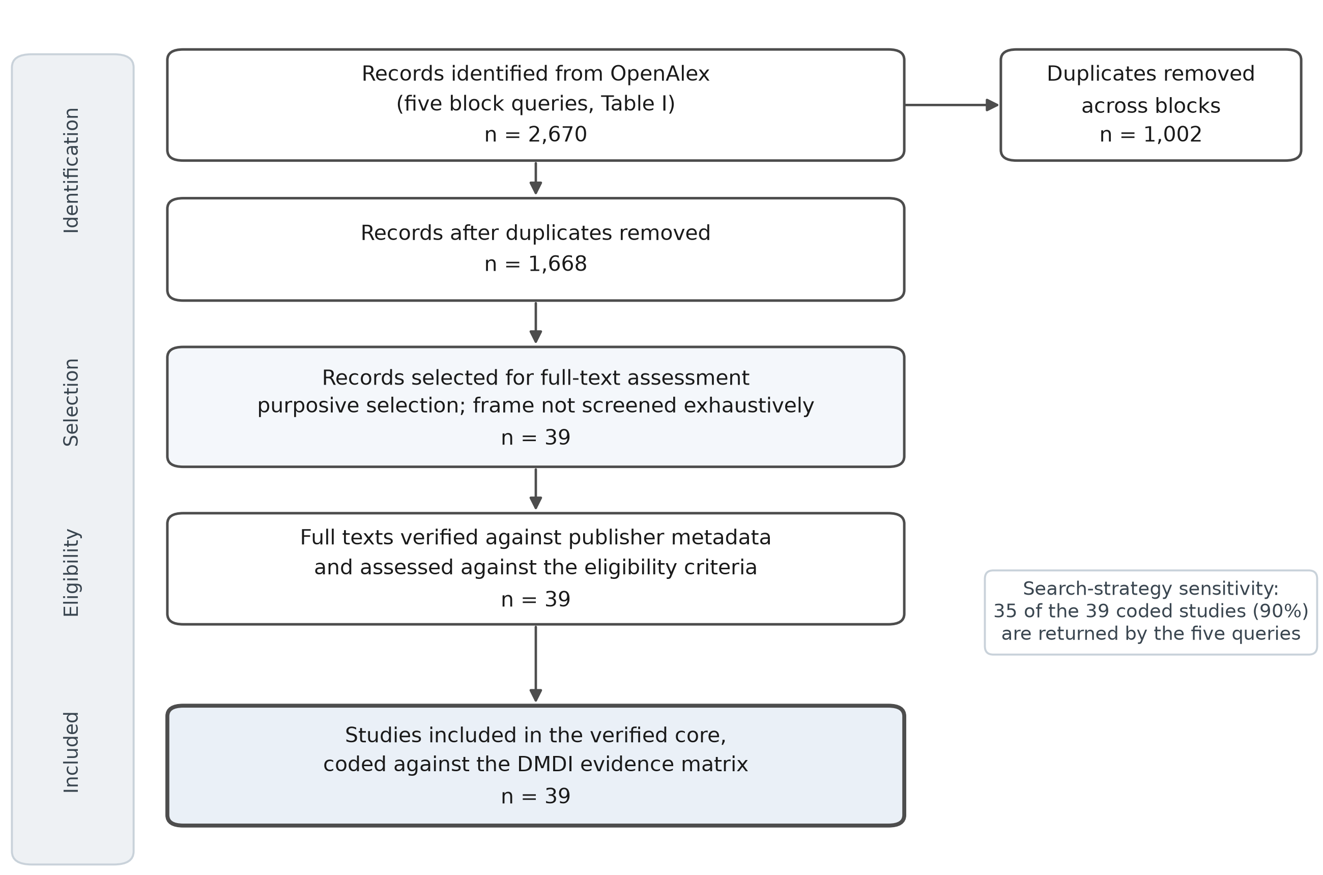
Fig. 1. PRISMA-aligned flow with executed identification counts. Records identified (2,670), duplicates removed (1,002), and the de-duplicated frame (1,668) are counted from Table I; the selection, eligibility, and inclusion boxes describe the purposive route to the 39-study verified core and are not an exhaustive screening cascade.

2.5 Data extraction fields
Each verified-core study is coded for: VPP architecture; DER composition; decision horizon; data source; forecasting method; uncertainty representation; dependence/scenario treatment; optimization paradigm; bidding mechanism; market products; carbon-integration level (Section 9.1); information-set definition; temporal split; out-of-sample testing; baseline quality; settlement model; computational reporting; reproducibility; deployment evidence; and Data-to-Market Maturity level (Section 10). A reference-verification status (Section 2.6) is maintained as a separate field so that bibliographic confidence is never conflated with methodological relevance.

2.6 Reference verification protocol
Every cited record was checked against at least one authoritative source — publisher metadata, a DOI resolver, or an indexing service — using a three-part check: (i) a metadata match for title, author list, venue, volume, and year; (ii) independent bibliographic cross-consistency across at least two records where available; and (iii) claim-to-source alignment, i.e. that any quantitative claim attributed to a source is actually present in it. Metadata checks were performed against Crossref DOI records and publisher landing pages. Records that could not be matched were removed before submission rather than retained with a caveat. Bibliographic verification is maintained as a coding field separate from methodological relevance (Section 2.5), so that bibliographic confidence is never conflated with methodological relevance.

2.7 Structured coding roles and AI-assisted coding disclosure
Literature identification, reference verification, and first-pass evidence coding for this review were structured around eight predefined analytical coding roles, used to divide the audit into tractable, cross-checked sub-tasks: (A) VPP concepts and architecture; (B) uncertainty, risk, and bidding; (C) data-driven and AI methods; (D) electricity, flexibility, and carbon markets; (E) deployment and practical barriers; (F) the complete decision chain; (G) evidence quality and validation; (H) reference verification. These are coding roles applied with the assistance of a large language model under direct researcher supervision, not independent human reviewers or a claim of formal inter-rater methodology; every output produced under a role was reconciled by the authors into a single study-level evidence matrix, and every reference appearing in the final list (Section 14) was individually cross-checked against a primary bibliographic source before inclusion (Section 2.6). This disclosure is made in accordance with IEEE author guidelines on the use of AI-generated content in submitted articles.
We flag explicitly, as a limitation rather than an omission, that this structured-coding process has not yet been validated by independent double-coding (e.g., a second, blinded human coder reproducing the DMDI ratings in Table XI and computing agreement such as Cohen’s κ). Reporting that the literature shows low explicit reproducibility (Section 10) while not yet demonstrating the reproducibility of our own coding process would be an internal inconsistency if left unaddressed; we therefore treat single-coder DMDI ratings as provisional and indicative, name double-coding as a required next step (Section 11.6, Section 12), and avoid any composite scoring that would present the current ratings as more settled than they are.

2.8 Risk-of-bias / evidence-quality layer (distinct from DMDI)
DMDI (Section 5) codes what evidence a study provides along the decision chain; it is not a risk-of-bias instrument and does not assess study quality independent of the chain. We therefore define a second, deliberately separate evidence-quality layer, adapted from PRISMA’s expectation that a systematic review report how study-level quality was assessed [9], summarized here as Q1–Q8 in Table II:

TABLE II — Evidence-quality assessment layer (Q1–Q8): coding criteria, kept separate from DMDI
ID | Question | What counts as satisfied
Q1 | Search/data transparency | Data source, horizon, and any pre-processing are stated in enough detail to identify the dataset
Q2 | Information-set validity | The paper states what information was available at each decision gate (see coding rule for I, Section 5)
Q3 | Temporal validation | Train/validation/test split is chronological, not random, for time-dependent series
Q4 | Baseline adequacy | At least one transparent, non-trivial baseline is reported alongside the proposed method
Q5 | Market realism | Market rules (products, timing, clearing) match a named, real jurisdictional mechanism or are explicitly stated as stylized
Q6 | Settlement realism | Deviation, imbalance, or penalty/reward mechanisms are modeled, rather than the ex-ante objective value alone
Q7 | Reproducibility | Code, data, or sufficient parameterization is available or described for independent replication
Q8 | Reporting completeness | Sample size / scenario count / computational effort are reported
The Q1–Q8 layer is applied qualitatively to the three comparator studies in Table VIII; full scoring of the verified core is left to future work, because scoring 39 studies without a second coder would reproduce the single-coder limitation identified in Section 2.7.

2.9 Reporting status of the evidence synthesis
This review is reported as a structured evidence review rather than as a completed PRISMA 2020 systematic review. Four elements of a systematic review are now reported in full: the eligibility criteria (Section 2.2), the executed retrieval with its record counts (Sections 2.3–2.4, Table I), the sensitivity of that retrieval against the analytical corpus (Section 2.4), and the reference-verification procedure (Section 2.6). Three elements remain incomplete and are stated as limitations rather than estimated: exhaustive title and abstract screening of the 1,668-record frame; independent double-coding of the DMDI ratings (Sections 2.7 and 11.6); and retrospective re-tagging of the existing not-reported entries into NR-R and NR-U (Section 5.3). Where a reported quantity depends on one of these unfinished steps — notably the per-dimension counts in Table XI — it is described as indicative of a pattern rather than as a prevalence estimate.

3. Existing Review Landscape
Table III positions this review against the principal prior reviews and against representative primary studies that anticipate parts of the decision-chain argument. The comparison is between literature lenses, not between review rankings: we do not claim novelty from combining topics that have already been reviewed separately, but from adding an explicit information-to-settlement evidence audit on top of them.

TABLE III — Literature streams and positioning of this review

Literature stream | Representative evidence | Primary contribution | What is validated | Limitation relative to DMDI
Data-driven reviews | Ruan et al. [4] | Data lifecycle, AI, privacy, market participation | Broad thematic coverage | Not a study-level information-to-settlement audit
Architecture/operation reviews | Gao et al. [5]; Kaiss et al. [6] | VPP coordination, operation, markets, ancillary services | Architectural and operational breadth | Evidence not normalized by decision-time information
Theory-to-practice reviews | Esfahani et al. [7] | Platforms, pilots, real-world implementations | Deployment evidence | Case heterogeneity limits direct methodological comparison
Market/carbon review | Zare et al. [8]; Wang et al. [16]; Fan & Liu [15] | Electricity, flexibility, carbon market-coupling taxonomies | Market-coupling and carbon-flow taxonomies | Settlement and information-set integrity are not the central coding unit
Sequential stochastic bidding (primary) | Wozabal & Rameseder [17] | Day-ahead + multi-auction intraday bidding, OOS comparison | Market-timing and out-of-sample value | Settlement mechanics require separate audit
Risk-aware scheduling (primary) | Vahedipour-Dahraie et al. [18] | CVaR, demand response, reserve, N-1 | Risk-sensitive operational decisions | Empirical OOS and settlement evidence remain limited
AI forecasting/bidding (primary) | Sadeghi et al. [19], [20]; Wang et al. [21]; Nadimi & Goto [22], [23] | Deep-learning forecasting and decision support | Forecast/policy performance | Forecast-to-market-value transfer not uniformly established
DRO/robust bidding (primary) | Li [24]; internal/external DRO [25]; Song et al. [26]; interval-robust [27] | Ambiguity-set, multi-uncertainty bidding | Robust decision quality under modeled uncertainty | Calibration and real settlement remain uneven
MARL/DRL (primary) | Wang et al. [28]; Xu et al. [29]; Wu et al. [30] | Autonomous/decentralized decision-making | Policy performance and coordination | Temporal generalization and market realism vary
Electricity–carbon coupling (primary) | Liu [31]; Liu et al. [32]; Wang et al. [33]; Bian et al. [34] | Joint electricity–carbon bidding/scheduling | Economic/environmental coupling | Accounting, decision, and settlement coupling not always separated
Settlement/market mechanism (primary) | PAB/PAC study [35]; DER portfolio study [10] | Auction and imbalance effects | Direct market/settlement sensitivity | Smaller literature than optimization-focused work
Those are not the only surveys in the field; Wang et al. (2025) is the closest carbon-focused review, examining carbon-flow modeling and electricity–carbon transactions [16], and none of the others closes the same gap. Naval and Yusta [36] catalogue VPP models against European market designs. Mo et al. [37] and Zhu et al. [38] survey deep-learning and reinforcement-learning applications in bidding and operation, Li et al. [39] give a broad AI-driven overview, and Singh et al. [40] concentrate on uncertainty management and bidding strategy. Bedi et al. [13] trace blockchain integration, Bendigiri and Rao [14] narrow the scope to the built environment, and Bhattarai et al. [12] review the policy and regulatory envelope. Each is a useful map of a sub-literature. None of them codes a primary study against the information that was actually available at its decision gate, which is the question Table III is built to make visible.

4. Synthesis Streams and Retrieval Blocks
The six retrieval blocks in Section 2.3 exist to maximize recall during search (so that uncertainty, AI, market, and carbon vocabulary are each retrieved even when a study does not use the phrase “VPP energy management” directly). They are a search-execution device, not a synthesis structure. For synthesis, the verified core is organized into five thematic streams, which is the level at which Sections 7–10 report results:
- Concept/architecture — VPP definitions, DER composition, coordination structures.
- Uncertainty/risk — stochastic, robust, DRO, and risk-averse representations and their calibration.
- Data-driven/AI — forecasting, deep learning, reinforcement learning, and hybrid learning–optimization methods.
- Market/carbon — electricity-market products, settlement mechanisms, and carbon/green-certificate coupling.
- Practical deployment — pilot, hardware-in-the-loop, and field-operational evidence.
Every verified-core study is tagged to at least one synthesis stream independently of which retrieval block(s) originally surfaced it, since a study retrieved via the carbon block, for example, may be synthesized primarily under uncertainty/risk if that is its main methodological contribution.

5. The DMDI Framework
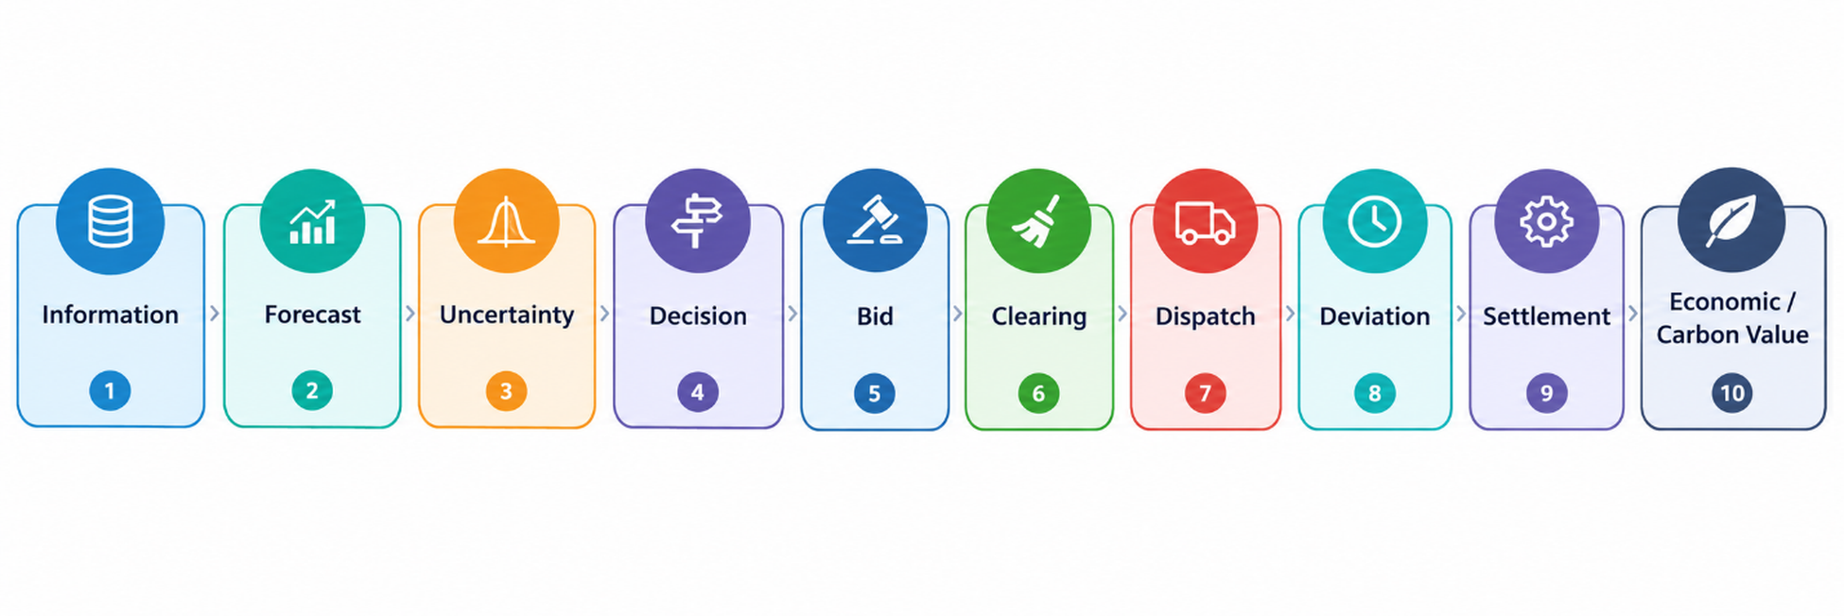
Fig. 2. Data-to-Market Decision Integrity (DMDI) chain. The final node, Economic/Carbon Value, is the realized value after settlement.

5.1 The decision chain and seven dimensions
VPP decision-making is treated as a continuous chain: Information → Forecast → Uncertainty → Decision → Bid → Clearing → Dispatch → Deviation → Settlement → Realized Value (Fig. 2). DMDI comprises seven evidence dimensions along this chain:
- Information-set integrity (I) — whether the study uses only information genuinely available at the decision gate being modeled.
- Uncertainty integrity (U) — whether uncertainty distributions, dependence, scenarios, and tails are empirically justified rather than merely assumed.
- Decision integrity (D) — whether the optimization or learning policy is evaluated under its own stated constraints, without look-ahead bias.
- Market realism (M) — whether market products, timing, clearing rules, and strategic assumptions correspond to a defined, named market setting.
- Out-of-sample validity (O) — whether performance is evaluated on chronologically unseen conditions rather than random splits or in-sample data.
- Settlement realism (S) — whether realized value is computed through a credible settlement mechanism (deviations, imbalance penalties/rewards), rather than the ex-ante objective value alone.
- Reproducibility (R) — whether data provenance, parameters, baselines, and evaluation procedures are reported in enough detail for independent reconstruction.
Deployment maturity is tracked as a companion field, P (Section 10), because operational evidence cannot be inferred from methodological sophistication alone.

5.2 Explicit coding rules
Each dimension is coded on a four-level evidence status: Explicit, Partial, NR-R (not reported), or NR-U (not verifiable from the available evidence, e.g., because full text was inaccessible or the claim could not be checked against a primary source). Coding rules, illustrated using out-of-sample validity as the worked example:
- O = Explicit if all three hold: (i) a chronological train/validation/test split or rolling-window evaluation is used; (ii) the test period is disjoint from and later than any period used for fitting/tuning; (iii) quantitative performance is reported specifically on that held-out period.
- O = Partial if temporal separation is mentioned but at least one of (ii)–(iii) is missing or ambiguous (e.g., the split is described only qualitatively, or results pool in-sample and out-of-sample periods).
- O = NR-R if the paper does not discuss temporal separation at all and does not claim otherwise.
- O = NR-U if the paper’s description is too incomplete (e.g., abstract-only access) to determine which of the above applies.
Analogous rules apply to the other six dimensions, substituting the relevant chain-link criteria — for example, S = Explicit requires that reported profit/cost figures are computed after applying a stated deviation or imbalance-settlement rule (not the optimization objective value alone), and R = Explicit requires that a reader could, in principle, reconstruct the reported experiment from the paper’s stated data source, parameters, and evaluation protocol without contacting the authors.
Those rules are qualitative on their own, and the counts reported in Sections 7–10 have to be something a reader can recompute. Two quantities carry most of the weight. Write r(i,d) = 1 when study i is coded Explicit on dimension d and 0 otherwise; the coverage index for a single study is then
$C_{i}=\frac{1}{7}\sum_{d=1}^{7}{r_{i,d}}$ (1)
and the observed explicit rate for a dimension across the n = 39 coded studies is
$p_{d}=\frac{1}{n}\sum_{i=1}^{n}{r_{i,d}}$ (2)
C(i) is the quantity that Fig. 7a plots as a histogram, and 39 times p(d) reproduces the explicit column of Table XI. Both are unweighted counts of Explicit cells. A Partial rating is not converted to a half-credit, because doing so would attach a cardinal meaning to an ordinal scale that the coding rules in this section do not give it; the cost is that the index is conservative, and the benefit is that every number in Sections 7–10 can be checked by counting cells in Table XI.

5.3 On NR-R vs. NR-U
“Not reported” conflates several different situations: a study may be silent on a dimension, or the dimension may not be determinable from the accessible text. The distinction is applied to all coding performed for this review. Disaggregating the NR entries already present in the Sections 7–10 tables into NR-R versus NR-U would require re-reading each of the affected primary sources against the two-way rule; this re-tagging pass has not yet been completed (Section 11.6). Table XI (Section 10) therefore reports a single combined NR column for the existing 39-study matrix, with the caveat stated here, while all tables introduced with the four-level scheme (e.g., Table VIII) use it directly.
DMDI is intentionally not collapsed into a single numerical score. This avoids arbitrary dimension weights and prevents strong evidence on one dimension from masking a critical gap on another. The preferred presentation throughout is a dimension-by-dimension evidence matrix (Fig. 5) supplemented by the maturity ladder (Section 10).

6. Decision Integrity: A Complementary Four-Layer Framework

6.1 Two instruments, two questions
This review uses two deliberately separate instruments, because they answer two different questions and rest on two different evidence bases. DMDI (Section 5) is an evidence-coding instrument applied per study along the data-to-market decision chain: it answers “what evidence does this specific paper provide?” The Decision Integrity framework introduced in this section is a conceptual threat-and-countermeasure taxonomy applied at the level of the literature as a whole: it answers “independent of what any given paper reports, what could cause a market-facing VPP decision to be wrong, unstable, or untrustworthy, and how mature are the available defenses?” Threats such as corrupted telemetry, adversarially perturbed forecasts, opaque bidding agents, and unverifiable carbon accounting are rarely the explicit subject of a bidding or scheduling paper, yet they bound how much confidence the field should place in a paper's reported value even when its DMDI ratings are strong.
Decision Integrity is therefore defined as the property that a VPP's market-facing decisions (bids, offers, schedules, and control setpoints) remain correct (consistent with true system state and market rules), robust (stable under uncertainty and distributional shift), and trustworthy (verifiable, explainable, and auditable) despite imperfect, incomplete, or adversarially manipulated inputs. It is organized into four layers — data, model, execution, and governance — each with representative threats and countermeasures rated by maturity. Table IV is a qualitative, literature-wide judgment by the authors, informed by the cybersecurity, robust-optimization, privacy, and market-design literatures cited throughout this section; it is not a re-coding of the 39-study verified core and does not carry the same evidentiary status as the DMDI tables in Sections 7–10 (Section 12).
The two instruments are complementary rather than overlapping: DMDI’s Information-set (I) and Reproducibility (R) dimensions correspond most closely to the Data (L1) and Governance (L4) layers below; DMDI’s Uncertainty (U) and Decision (D) dimensions correspond most closely to the Model layer (L2); and DMDI’s Market (M) and Settlement (S) dimensions correspond most closely to the Execution layer (L3). Where DMDI shows a literature-wide gap (Section 10.1: O, S, and R are weak), the Decision Integrity layers below make explicit why such gaps are consequential and what would close them.

6.2 The four layers

TABLE IV — Decision-integrity threats and countermeasures by layer (qualitative, literature-wide)

Layer | Integrity question | Representative threats | Countermeasures (maturity)
L1: Data | Do inputs reflect reality? | Missing/corrupt telemetry; false data injection (FDI) [41], [42]; clock skew; meter tampering | Bad-data detection, robust state estimation (high); FDI detectors, physics-informed validation (medium); redundancy and attestation (medium)
L2: Model | Do models stay valid? | Distributional shift invalidating scenario sets; adversarial perturbation of learned forecasters/bidders [43]; miscalibration; opacity | Proper scoring rules and calibration diagnostics (high); distributionally robust optimization [44] and adversarial training (medium); post-hoc explainability, SHAP [45]/LIME [46] (medium–low); digital-twin stress testing [47] (low–medium)
L3: Execution | Are market actions faithful? | Network-infeasible offers; market-power abuse in thin markets; carbon-baseline gaming; settlement disputes | Pre-submission feasibility screening (high); market monitoring (high); ledger-anchored settlement and audit trails [48] (medium); strategy explainability (low)
L4: Governance | Can decisions be audited? | Opaque AI bidders; prosumer privacy exposure; unverifiable MRV (measurement, reporting, verification) for carbon claims | Logging and reproducibility standards (medium); federated learning [49] with differential privacy (medium); regulatory compliance, e.g., GDPR-type regimes (high); ledger-based MRV trails [48] (medium–low)
The layers are ordered by proximity to raw data, but failures propagate both upward (bad data corrupts bids) and downward (unverifiable markets invite data manipulation). A distinction worth making explicit within L1: generic state-estimation FDI research asks whether an attack evades a residual-based bad-data detector [41], [42], whereas a more recent, market-specific strand asks whether an attack is profitable under the two-settlement market design itself — i.e., whether the attacker’s objective is stated directly in market currency rather than in generic system-cost terms [50]. This reframing matters for VPPs specifically, because it converts data integrity from a physical-security question into the same market-currency terms used elsewhere in this review’s Decision Integrity accounting, and it is the reasoning behind treating L1 as a market property rather than a purely engineering one (Section 6.1). Network feasibility belongs to the execution layer for the same reason: locational marginal flexibility formulations [51], and the temporal-coupling work of Wang and Wu [52] can leave an offer technically infeasible after clearing, which turns a power-flow detail into a market-integrity question. Solution technologies cut across layers: decomposition methods such as ADMM [53] and Benders decomposition [54] support scalable, privacy-preserving coordination (L1/L4), while game-theoretic tools — Nash equilibrium analysis [55] and Shapley-value surplus sharing [56] — support execution-layer (L3) monitoring of strategic behavior in coupled or thin markets.

6.3 Uncertainty taxonomy and decision paradigms
To complement DMDI’s per-study Uncertainty (U) and Decision (D) coding (Section 8.1) with a literature-wide conceptual map, Table V classifies VPP uncertainty sources by timescale and character, and Table VI compares six decision paradigms on the dimensions that determine what market value each can credibly promise.

TABLE V — Taxonomy of VPP uncertainties

Source | Timescale | Character | Standard treatment
Wind/solar output | Minutes–days | Aleatoric, correlated, non-Gaussian | Probabilistic forecasts; scenario generation; storage buffering
Load and prosumer behavior | Minutes–days | Partly epistemic, behavioral | Probabilistic load forecasting; demand-response contracts
Day-ahead/intraday/balancing prices | Hours–days | Strategic, fat-tailed, regime-switching | Scenario trees; price-arbitrage recourse across market floors
Carbon/allowance prices | Days–years | Policy-driven, jump-prone | Hedging; tiered trading; energy–carbon co-optimization
Outages and contingencies | Seconds–hours | Rare, high-impact | Reserve procurement; CVaR-based tail control [57]
Model and parameter error | All | Epistemic | Robust/distributionally robust ambiguity sets [44]; info-gap satisficing [58]

TABLE VI — Decision paradigms for VPPs under uncertainty
Paradigm | Uncertainty input | Guarantee / objective | Cost and data appetite
Deterministic + point estimate | Point forecast (+ moments) | Optimal for the nominal case | Low cost; fragile to tail events
Stochastic programming (SP) | Scenarios with probabilities | Optimal in expectation; explicit recourse | High (scenario growth); needs credible distributions [59]
Chance-constrained programming (CCP) | Distributions | Feasibility with probability 1−ε | Medium; tractable mainly for Gaussian/affine cases [60]
(Adaptive) robust optimization (RO/ARO) | Uncertainty sets | Feasible for all realizations in the set; worst-case optimal | Medium; conservative unless the set is tuned [61], [62]
Distributionally robust optimization (DRO) | Ambiguity set of distributions | Worst-case expectation over plausible distributions | Medium–high; data-driven calibration [44]
Info-gap decision theory (IGDT) | Horizon of uncertainty | Maximum robustness to severe, non-probabilistic uncertainty | Low–medium; no probability distribution required [58]
No paradigm dominates: SP maximizes expected value when scenario distributions are trustworthy but degrades when they are not; RO/DRO purchase reliability at a measurable “price of robustness” [61]; IGDT protects against genuinely unknown uncertainty horizons (e.g., unprecedented carbon-price regimes) but offers no expected-value optimality claim. Read against DMDI, paradigm choice is itself an information-integrity commitment: each paradigm makes a different promise about what it does not know, and the DMDI Uncertainty (U) and Decision (D) ratings in Table VIII (Section 8.1) should be interpreted in light of which promise a given study is making, not compared as if all six paradigms targeted the same guarantee.

6.4 Electricity–carbon coupling archetypes
Section 9.1 codes, per study, how deeply a given paper integrates carbon accounting into its decision model (a six-level evidence scale). Table VII complements this with a six-archetype mechanism-design taxonomy describing how the electricity–carbon literature as a whole structures the coupling, ordered by integration depth.

TABLE VII — Electricity–carbon coupling archetypes
# | Archetype | Mechanism | Strengths | Integrity/risk caveats
A1 | Exogenous carbon adder | A carbon price is added to fossil marginal cost outside the decision model | Simple; compatible with existing dispatch logic | Ignores carbon-price uncertainty; no MRV feedback loop
A2 | Emission-flow accounting | Network carbon intensities are attributed to loads/VPP nodes | Physically grounded; enables nodal carbon signals | Depends on flow-data integrity; allocation-rule disputes
A3 | Sequential two-stage trading | Electricity is cleared first, carbon settled afterward on a separate cadence | Matches real market tempos; computationally tractable | Post-hoc carbon settlement provides weak dispatch-time incentive
A4 | Hierarchical co-optimization | Leader–follower or bi-level electricity–carbon coordination | Captures strategic interaction between markets | Computationally heavy; equilibrium-selection issues
A5 | Joint clearing / energy-credit markets | Energy and environmental value are co-cleared in a single mechanism | Strongest incentive alignment between electricity and carbon signals | Nascent market design; liquidity and market-power concerns
A6 | Tiered (ladder) carbon pricing | Marginal carbon price rises with emission bands | Rewards deep emissions cuts progressively | Baseline-setting integrity is decisive; gaming-prone if MRV is weak
The verified-core evidence in Table X (Section 9.1) concentrates at A1–A3: exogenous adders and emission-flow accounting are common, and sequential two-stage trading appears in several recent studies [31], [32], [15]. Deeper integration (A4–A6) — bi-level coordination, joint energy-credit clearing, and tiered pricing — appears mostly in the most recent studies [34], [63], [64] and aligns with the review-level observation in Section 9.2 that carbon–electricity coupling methodology is still consolidating. Every coupling archetype ultimately rests on MRV integrity (Table IV, L4): without trustworthy emission attribution, carbon-coupled VPP revenue rests on an unverifiable foundation, regardless of how sophisticated the coupling mechanism is.

6.5 Enabling technologies and their integrity/maturity trade-offs
Four technology families recur across the Decision Integrity literature, each trading value for a distinct integrity cost:
- Reinforcement learning for forecasting and bidding. RL and deep-learning bidding agents, including hierarchical schemes for aggregated heterogeneous microgrids [65], adapt to nonstationary prices and behavior that static scenario sets miss, but they are comparatively opaque and can be destabilized by adversarial or out-of-distribution inputs [43]; constrained and explainable RL variants are an active bridge technology.
- Distributed optimization and decomposition. ADMM-based coordination [53] and Benders decomposition [54] let large, heterogeneous DER portfolios be optimized without a single centralized model of every asset, simultaneously improving scalability, privacy (L4), and resilience to single points of failure — a rare case where a value-driven technique also improves integrity.
- Blockchain and smart-contract settlement. Ledger-anchored logs of offers, meter readings, and carbon-credit transfers make ex-post verification cheap [48], directly supporting L3/L4 auditability; throughput, energy cost, and the “oracle problem” (a ledger cannot verify off-chain meter truth on its own) keep maturity medium–low, a verdict shared by review-level assessments of blockchain integration in VPPs [13].
- Digital twins and federated/privacy-preserving learning. High-fidelity replicas of VPP portfolios support pre-market stress-testing of bidding policies under simulated attack or drift [47]; federated learning [49] allows prosumer-level models to train without raw-data egress, addressing the privacy tension in L4 governance.
The pattern across these technologies mirrors the DMDI finding in Section 10.1: technologies closest to raw market value (forecasting, RL bidding) matured first, while integrity-enabling technologies (explainability, ledger-anchored audit, federated/privacy-preserving coordination) remain comparatively immature — the same information-to-settlement and execution-to-governance imbalance, seen here from a technology-maturity angle rather than a per-study evidence angle.

7. Results: Information and Forecast Integrity
Across the verified core, information-set integrity (I) is the dimension most consistently reported: 22 of 39 studies (56%) provide explicit information-set definitions (measurement timestamps, forecast publication time, or market gate closure), and a further 17 provide partial evidence, with no study coded NR on this dimension. This is consistent with the fact that most bidding and scheduling formulations must, by construction, state what is known at the bidding stage even if they do not audit it against real-world timing.
Forecast integrity is treated in this review as an intermediate metric, not an endpoint. Recent forecasting work addresses data scarcity through transfer-learning and adversarial graph mechanisms for distributed PV [21], long-horizon recursive forecasting via BiLSTM-based decision support [23], and explicit uncertainty reduction from day-ahead to balancing markets [22]. Work on the demand side, such as data-mining-driven incentive design for aggregated response [66], improves the input layer in much the same way. These studies strengthen the forecasting layer, but their contribution to realized market value must be judged by whether the forecast improvement changes the resulting bidding decision under the same information set — the FQ → UQ → DQ → MV distinction used throughout this review (Section 1). A forecasting paper reporting lower MAE without a demonstrated operational or bidding consequence is classified as predictive evidence only, not market-value evidence.

8. Results: Uncertainty, Decision, and Market/Settlement Integrity

8.1 Uncertainty and decision integrity
The literature shows a clear methodological progression from deterministic scheduling toward stochastic programming (scenario trees) [18], [67], including robust stochastic multi-energy dispatch [68], through interval, two-stage, and price-maker robust variants [69], [70], [71], and day-ahead bidding formulations for renewable portfolios [72], to distributionally robust optimization (DRO), increasingly Wasserstein-metric-based and dominant since approximately 2023 [24], [15], [25], [73], including Wasserstein scheduling formulations [74]. Decision integrity (D) is well reported overall (32/39 explicit, 7/39 partial, 0 NR), reflecting that most optimization-focused papers do specify their constraint sets; market realism (M) is similarly strong (31/39 explicit, 8/39 partial). Uncertainty integrity (U) is explicit in 23/39 studies and partial in 15/39, with one NR.
However, methodological sophistication in uncertainty representation does not by itself establish uncertainty validity. Three distinctions matter. First, uncertainty representation differs from uncertainty calibration: a Gaussian or empirical distribution can be embedded in an optimization model without demonstrating that it reproduces the relevant error distribution. Second, marginal accuracy differs from dependence integrity: separately calibrated wind, PV, load, and price distributions may fail to reproduce cross-variable and temporal dependence. Third, in-sample risk control differs from out-of-sample risk control: a risk measure such as CVaR is decision-relevant only when the loss distribution used for evaluation reflects the conditions encountered after the bid or schedule is fixed.

TABLE VIII — Comparative evidence for uncertainty transfer and decision integrity (illustrative Q1–Q8 tags shown for the three most methodologically distinct entries)
Study | Uncertainty method | I | U | D | O | Maturity | Q1–Q8 (illustrative)
Wozabal & Rameseder (2020) [17] | Multi-stage stochastic | Explicit | Explicit | Explicit | Explicit | Level 4 | Q1–Q5 met; Q6 partial; Q7 partial
Vahedipour-Dahraie et al. (2020) [18] | Stochastic + CVaR | Partial | Explicit | Explicit | NR | Level 1 | —
Falabretti et al. (2023) [67] | Stochastic + rolling horizon | Explicit | Explicit | Explicit | Partial | Level 4 | —
Fan & Liu (2024) [15] | Wasserstein DRO + DRCC | Explicit | Explicit | Explicit | NR | Level 2 | Q1, Q2, Q5 met; Q6 partial; Q7 not met
Li (2024) [24] | Semi-anticipative DRO | Explicit | Explicit | Explicit | NR | Level 2 | —
Kim & Choi (2024) [75] | Sample-robust + real business data | Explicit | Explicit | Explicit | Explicit | Level 5 | Q1–Q4 met; Q6 partial; Q7 partial
Ma et al. (2025) [27] | Data-driven interval robust | Explicit | Explicit | Explicit | NR | Level 2 | —
Song et al. (2025) [26] | DRO + discrete scenarios | Explicit | Explicit | Explicit | NR | Level 2 | —
Bian et al. (2026) [34] | CVaR + energy/regulation/carbon | Explicit | Explicit | Explicit | NR | Level 2 | —

8.2 Market and settlement integrity
Market realism is comparatively well established, but settlement realism (S) is markedly weaker: 4/39 studies explicit, 18/39 partial, 17/39 NR. Market-mechanism studies that explicitly model pay-as-bid/pay-as-clear rules and imbalance penalties [35], studies that clear frequency-constrained products [76], scalable frequency-regulation co-optimization [77], and portfolio-composition studies that link DER composition to settlement outcomes [10], illustrate why settlement deserves independent treatment from market-clearing realism: a study can model realistic clearing (M = Explicit) while still computing reported profit from the ex-ante objective rather than from post-deviation settlement (S = Partial or NR).

TABLE IX — Electricity-market, settlement, and carbon-market evidence
Study | Market structure | Settlement | Carbon | O | Maturity
Wozabal & Rameseder (2020) [17] | Day-ahead + six intraday auctions | Partial | NR | Explicit | Level 4
Liu (2022) [31] | Electricity + intraday DR + regulation + real-time + carbon | Partial | Explicit | NR | Level 1
Fan & Liu (2024) [15] | Electricity–carbon coupled market | Explicit | Explicit | NR | Level 2
Liu et al. (2024) [32] | Electricity–carbon joint + CCER + DR | Partial | Explicit | NR | Level 1
Song et al. (2025) [35] | Pay-as-bid / pay-as-clear + imbalance penalties | Explicit | NR | NR | Level 2
Kim & Choi (2024) [75] | Wholesale, settlement-aware DER portfolio design | Partial | NR | Explicit | Level 5
Bian et al. (2026) [34] | Energy + regulation + carbon | Partial | Explicit | NR | Level 2

8.3 The Optimization-to-Settlement Evidence Gap
The single most consequential pattern in Sections 8.1–8.2, in our reading, is that the chain Objective value → Cleared value → Delivered value → Settled value is rarely reported in full. Of the verified core, most uncertainty-handling and market studies, including two-step spot-market formulations [78], report objective-function or cleared-market value; substantially fewer report the value that would remain after physical deviations and settlement penalties are applied (S explicit in only 4/39 studies). This is not evidence that reported gains are wrong — many studies explicitly and reasonably target theoretical upper-bound performance rather than deployment-readiness — but it means that a reported “profit improvement” should be read, by default, as an objective-value or cleared-value claim unless the study explicitly states otherwise. We treat this Optimization-to-Settlement Evidence Gap as a central, citable finding of this review (see also Section 10.1) rather than an incidental observation (Fig. 3), and recommend that future studies report which of the four stages their headline number corresponds to.
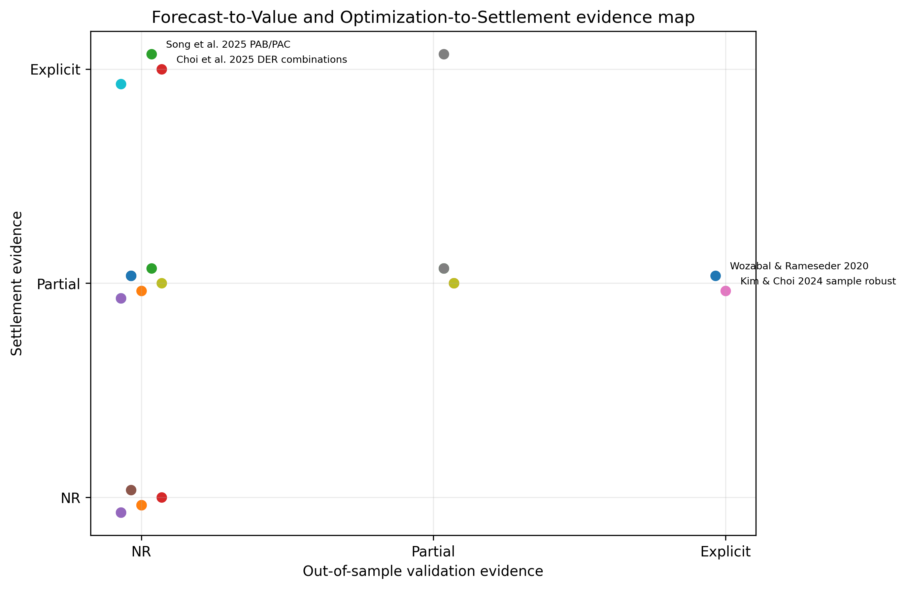
Fig. 3. Forecast-to-Value and Optimization-to-Settlement evidence map.

9. Results: Electricity–Carbon Market Integration

9.1 A six-level carbon-coupling coding scheme
Carbon integration is often recorded only as present or absent in the objective function, which is too coarse for a review organized around the decision chain. We therefore use an explicit six-level coding scheme, applied qualitatively to the carbon-relevant studies. Table X covers six studies from the DMDI-coded core plus [33], which is cited in Section 9.2 but falls outside that coding set:
- Accounting coupling — a carbon emission factor or intensity is reported or referenced, without appearing in the decision model.
- Objective coupling — a carbon cost or revenue term appears in the objective function.
- Constraint coupling — carbon emissions or allowances appear as an explicit constraint (e.g., an emissions cap).
- Market-participation coupling — the VPP explicitly participates in a modeled carbon-trading or green-certificate market alongside electricity markets.
- Clearing coupling — carbon-market clearing (price formation, allocation) is modeled with its own mechanism rather than treated as an exogenous price series.
- Settlement/coupled-decision coupling — realized carbon value is computed after settlement, and the electricity and carbon decisions are shown to interact (e.g., a carbon-price change is shown to alter the electricity bid).

TABLE X — Carbon-coupling level of representative studies
Study | Accounting | Objective | Constraint | Market participation | Clearing | Settlement/coupled decision
Liu (2022) [31] | ✓ | ✓ | ✓ | ✓ | Partial | Partial
Liu et al. (2024) [32] | ✓ | ✓ | ✓ | ✓ | Partial | NR
Wang et al. (2024) [33] | ✓ | ✓ | ✓ | Partial | NR | NR
Fan & Liu (2024) [15] | ✓ | ✓ | ✓ | ✓ | Partial | Partial
Bian et al. (2026) [34] | ✓ | ✓ | ✓ | ✓ | Partial | NR
Siqin et al. (2025) [63] | ✓ | ✓ | ✓ | ✓ | Partial | NR
Wang et al. (2025) [16] | ✓ | ✓ | Partial | ✓ | NR | NR
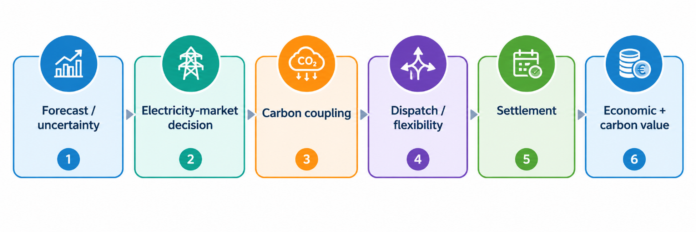
Fig. 4. Electricity–carbon value propagation.
Most carbon-integrated studies reach Level 2–4 (objective, constraint, and market-participation coupling); very few reach Level 5–6 (Fig. 4). This indicates that the field has moved well beyond treating carbon as a static accounting term, but has not yet widely demonstrated that carbon-market clearing and settlement interact dynamically with the electricity-side decision — the gap identified at the review level by [8] and [16] and echoed in the primary literature surveyed here.
This six-level accounting scheme is evidence-oriented (what a given study demonstrates); Section 6.4 complements it with a mechanism-design taxonomy of six electricity–carbon coupling archetypes (Table VII) that classifies how the literature as a whole structures the coupling, independent of what any single study happens to report.

9.2 The remaining review-level gap
Taken together with [8], [16], [33], [63], [64], and [79],, the evidence indicates that primary research on electricity–carbon coupling is accelerating faster than review-level synthesis of its methodology. We identified Wang et al. (2025) as the closest carbon-focused review, which examines carbon-flow modeling and electricity–carbon transactions; we did not identify one focused specifically on settlement-valid carbon-value evidence, dynamic emission-factor treatment, or the interaction between carbon-price volatility and electricity-bidding uncertainty. This remains, in our assessment, the most defensible and currently supported gap this review can claim in its carbon-market discussion.

9.3 A sharper statement of the gap: the missing VPP-level two-market model
The evidence in Sections 9.1–9.2 supports a more specific version of the carbon gap, worth stating explicitly because it converts a general observation (“carbon coupling is under-reviewed”) into a concrete, buildable research target. At the generation-fleet and market-design level, work on the coupling between carbon-trading and tradable-green-certificate mechanisms under electricity marketization shows that these two instruments interact through investment behavior and price formation in ways that a single-instrument model misses [80], and this fleet/policy-level coupling logic is structurally the same two-market problem — jointly manage an energy position and a carbon-related position under correlated uncertainty — that a VPP-level model would need. At the aggregator level, by contrast, the coding in Table X shows that most carbon-integrated studies treat the carbon price as a fixed scalar in the objective (archetypes A1–A2, Section 6.4; coupling levels 1–2, Section 9.1) rather than as a traded, uncertain position; explicit allowance buy/bank/sell decisions alongside the energy bid, with carbon price treated as a full uncertainty object rather than a constant, are essentially absent from the verified core. The missing piece is therefore not a new algorithm — two-market stochastic and DRO programming already exists in the fleet/policy-coupling literature [33], [15], [80], and market-trigger scheduling has been explored at the VPP level [81], and border-carbon-pricing analysis shows the same “price on a subset of the generation mix” logic extends naturally to trade-exposed operation [82] — but its transplantation to the aggregator, where the portfolio is smaller, the assets are behind the meter, and the carbon-displacement claim is only as credible as the metering that supports it (Section 6.2, L1). This framing of the gap is corroborated by convergent findings across the electricity–carbon literature [8], [80], which strengthens confidence that it reflects a structural gap rather than an artifact of this review's search strategy or verified core.

10. Results: Maturity, Out-of-Sample Validity, and Reproducibility

10.1 Central finding: information-to-settlement validation, not algorithmic sophistication, is the binding constraint
We propose the following as the central finding of this review, directly supported by the verified-core coding: the principal weakness of contemporary VPP research is not the absence of advanced optimization or learning methods, but the incomplete validation of the information-to-settlement pathway. Within the verified core, out-of-sample validity is explicit in only 2/39 studies (partial in 5, NR in 32); settlement realism is explicit in only 4/39 (partial in 18, NR in 17); reproducibility is explicit in 0/39 studies (partial in 38, NR in 1). By contrast, decision integrity and market realism are each explicit in over 75% of studies. This asymmetry — strong evidence at the modeling layer, weak evidence at the validation and settlement layer — is consistent with, and reinforces, the theory–practice gap identified independently in [7]. The same asymmetry can be read the other way round: the literature compares VPP decision-method families far more often on revenue than on auditability, which mirrors, from a different angle, this review's own Optimization-to-Settlement Evidence Gap (Section 8.3).
We restate the caveat from Section 2.7 here because it is directly relevant to this finding: these counts come from a single structured-coding pass that has not yet been independently double-coded, so they should be read as indicative of a pattern, not as a precise, externally validated prevalence estimate. We consider the direction of the pattern (O and R far weaker than I, D, and M) more robust than the exact counts, because it recurs consistently across the market/settlement (Table IX), carbon (Table X), and AI/forecasting (Table XII) evidence groupings independently.
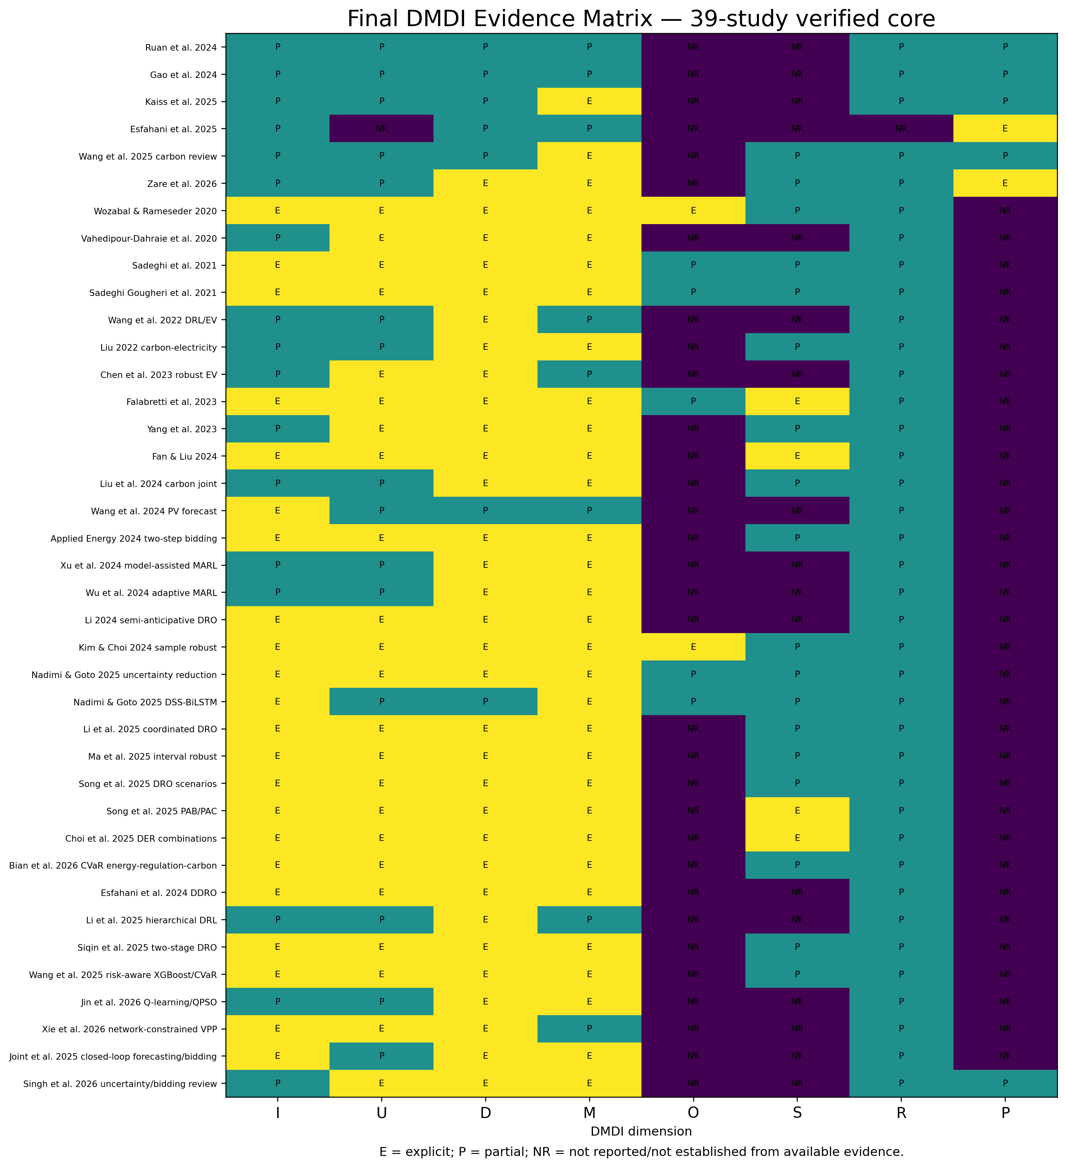
Fig. 5. DMDI evidence matrix, verified core (E = explicit; P = partial; NR = not reported/not established from available evidence).

TABLE XI — DMDI evidence coverage in the 39-study verified core
DMDI dimension | Explicit | Partial | NR (combined; NR-R/NR-U split pending re-tagging, Section 5.3)
I — Information-set integrity | 22 | 17 | 0
U — Uncertainty integrity | 23 | 15 | 1
D — Decision integrity | 32 | 7 | 0
M — Market realism | 31 | 8 | 0
O — Out-of-sample validity | 2 | 5 | 32
S — Settlement realism | 4 | 18 | 17
R — Reproducibility | 0 | 38 | 1
P — Deployment maturity (companion field, not a DMDI dimension) | 2 | 5 | 32

10.2 AI/forecasting evidence and the forecast-to-value pathway

TABLE XII — AI/forecasting evidence and the forecast-to-value pathway
Study | AI/forecasting role | I | D | O | Maturity
Sadeghi et al. (2021) [19] | BiLSTM + day-ahead energy/frequency regulation | Explicit | Explicit | Partial | Level 4
Sadeghi Gougheri et al. (2021) [20] | BiLSTM + energy/spinning reserve | Explicit | Explicit | Partial | Level 4
Wang et al. (2024) [21] | Adversarial GNN for data-scarce PV forecasting | Explicit | Partial | NR | Level 2
Xu et al. (2024) [29] | Model-assisted MARL | Partial | Explicit | NR | Level 1
Wu et al. (2024) [30] | Adaptive MARL | Partial | Explicit | NR | Level 1
Nadimi & Goto (2025) [22] | Forecast correction, day-ahead to balancing | Explicit | Explicit | Partial | Level 3
Nadimi & Goto (2025) [23] | DSS-BiLSTM, 38-hour day-ahead forecast | Explicit | Partial | Partial | Level 3
A conceptual distinction worth foregrounding, consistent with critiques in the broader forecasting-and-decision literature and echoed in [4], is that forecast accuracy and realized decision value are not interchangeable evidence claims. Closed-loop designs that train the forecast against the bidding objective rather than against forecast error alone [11] make the distinction concrete. Because balancing markets frequently apply asymmetric imbalance prices, a bidding policy built on a slightly less accurate but imbalance-aware forecast can outperform, in realized market value, a policy built on a more accurate but imbalance-agnostic point forecast. We propose this forecast-to-decision-value distinction as an interpretive lens for this review rather than as an already-quantified literature-wide finding.

10.3 The Data-to-Market Maturity Ladder
To compare heterogeneous studies without collapsing methodological novelty and validation maturity into one axis, we use an eight-level ladder (Table XIII). The ladder describes the strength of empirical validation and deployment evidence, not the scientific quality of an algorithm in isolation — a Level 1 conceptual DRO formulation is not thereby a weaker piece of mathematics than a Level 6 heuristic pilot; it simply carries different evidence for deployment claims.

TABLE XIII — Data-to-Market Maturity Ladder coding rules
Level | Status | Minimum evidence expectation
0 | Conceptual | Architecture or formulation without empirical validation
1 | Synthetic simulation | Synthetic or fully assumed data with computational demonstration
2 | Historical-data study | Historical measurements or market data used for evaluation
3 | Temporal out-of-sample | Chronological train/test separation or rolling evaluation
4 | Market-realistic | Explicit market timing, products, constraints, realistic bidding/clearing
5 | Settlement-aware | Deviation, imbalance, penalty, or settlement/accounting mechanisms modeled
6 | Pilot validation | Evidence from a pilot, field demonstration, or operational test environment
7 | Operational deployment | Sustained real-world operation with documented performance
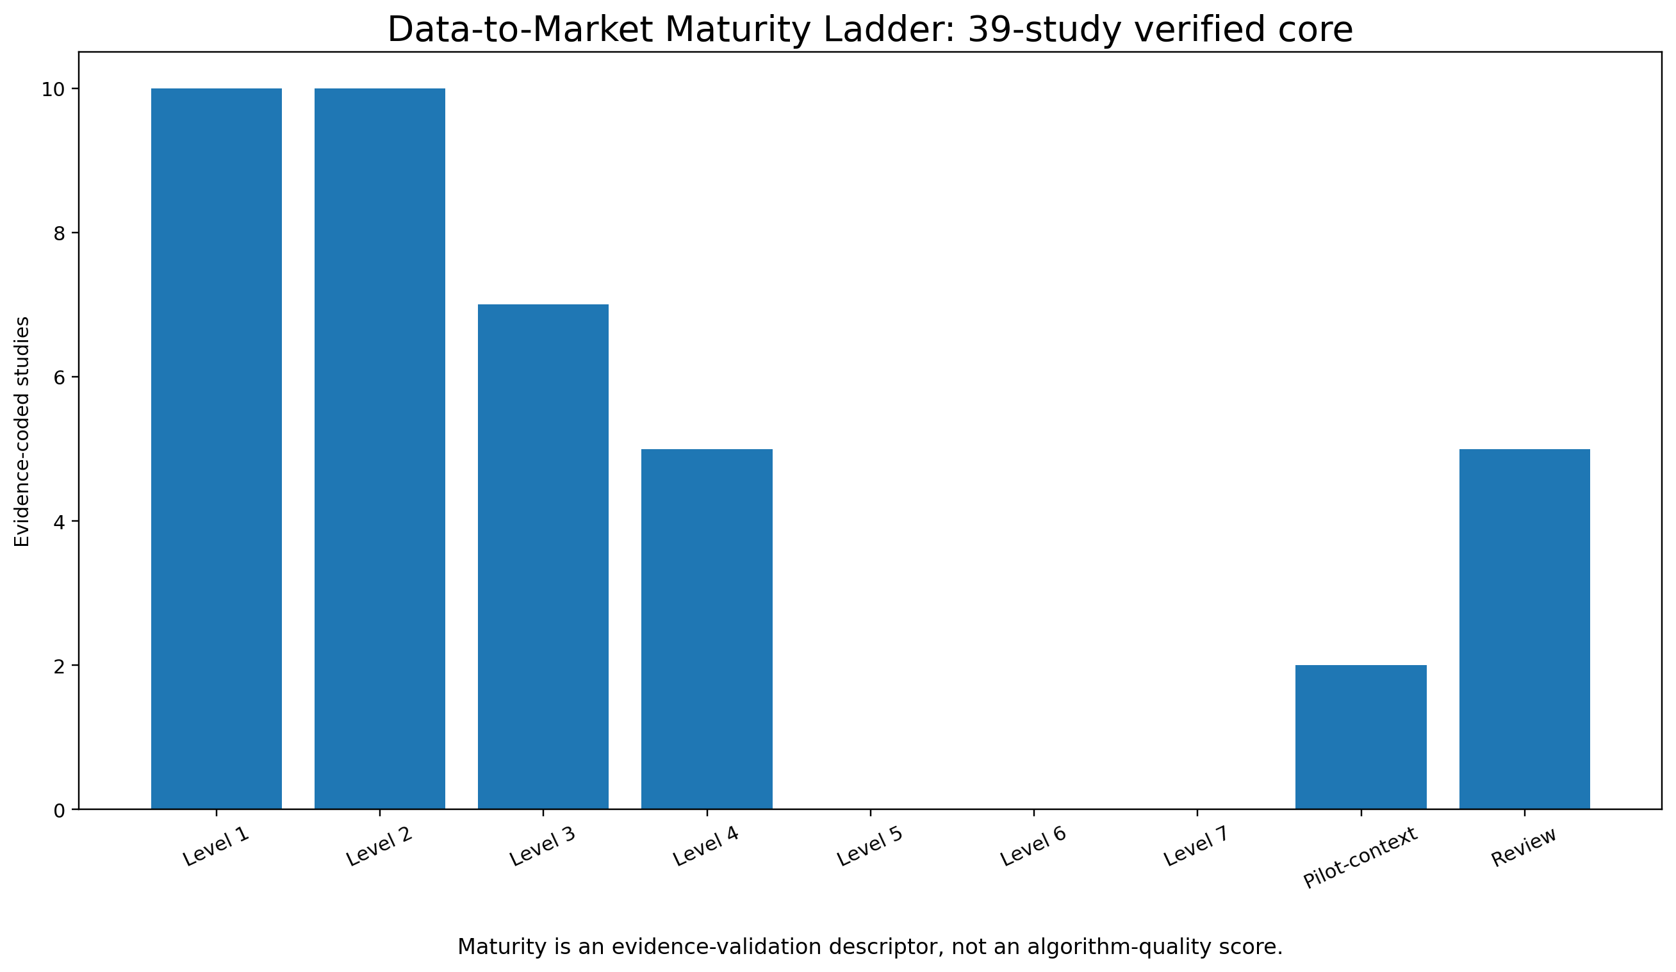
Fig. 6. Data-to-Market Maturity Ladder coverage in the verified core.
Based on the verified core, the literature clusters at Levels 1–4. The rungs above 4 are sparsely populated: the settlement-aware portfolio study [75] sits at Level 5, and no study in the verified core reaches Level 6 or 7 (Fig. 6), which means that no coded paper reports pilot or sustained operational evidence. The ladder records the highest rung a study demonstrably reaches and is not treated as strictly cumulative, so a study with explicit market realism but only partial temporal separation is placed at Level 4 while its O rating is carried unchanged in the DMDI column. A precise distribution across the full literature is deferred until database-level screening (Section 2.4) is complete; the clustering itself recurs in every evidence table in Sections 7–10.

10.4 The statistical structure of the verified-core coding
Table XI describes each dimension on its own. It does not say whether the dimensions move together, and that matters for how the central claim of this review should be read. If out-of-sample validity and settlement realism were rare only among studies that are also weak on information, uncertainty, decision, and market integrity, then the diagnosis would reduce to a statement about study quality in general, and little would follow from it beyond a call for better papers. So we examined the joint structure of the coded matrix rather than the marginals alone.
Formally, the association between two dimensions a and b is read off the 2×2 table of their joint coding, with n11 the studies explicit on both, n10 explicit on a but not b, n01 on b but not a, and n00 on neither. The coefficient is
$φ=\frac{n_{11}n_{00}−n_{10}n_{01}}{\sqrt{n_{1·}n_{0·}n_{·1}n_{·0}}}$ (3)
Significance comes from a two-sided Fisher exact test on the same table rather than from an asymptotic χ² statistic: in fourteen of the fifteen pairs the smallest expected count falls below five, and in six it falls below one. Fifteen tests are run, so the false-discovery rate is controlled with the Benjamini–Hochberg step-up, in which the adjusted value attached to the k-th smallest observed p is
$q_{(k)}=\min_{j≥k}{\frac{mp_{(j)}}{j}}$ (4)
with m = 15. Table XIV reports the raw p and the adjusted q side by side. The claim that two dimensions belong to the same block rests on q, not on p; the one pair that is significant before correction and not after (D–M) is reported but not used as evidence of a block.
Two facts are visible before any test is run. No study in the core is explicit on more than five of the seven dimensions, and the median is three; the distribution is unimodal and sits in the middle rather than piling up at either end (Fig. 7a). The three studies that carry no explicit dimension at all are all review articles ([4], [5], [7]); the two other reviews in the core are explicit on at least one dimension, which is why they do not appear at zero. That is the expected result rather than a criticism: a review synthesizes other people's evidence and does not report its own information set, hold-out split, or settlement calculation. We read the zero column as a property of the review genre and exclude nothing on that basis.
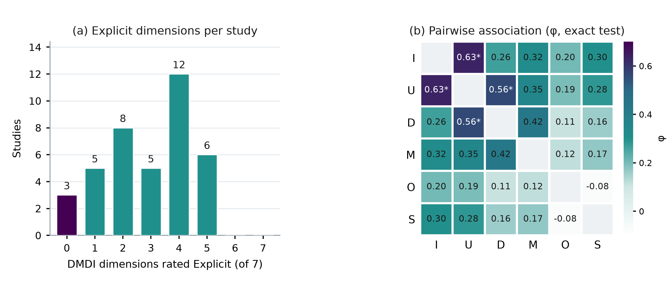
Fig. 7. Joint structure of the verified-core coding. (a) Number of DMDI dimensions rated Explicit per study; the bar at zero is the three review studies. (b) Pairwise φ between dimensions, with an asterisk marking pairs that survive Benjamini–Hochberg correction at q < 0.05. R is omitted from both panels because no study in the core is explicit on it.
The association analysis splits the dimensions into two blocks. Information-set, uncertainty, and decision integrity are positively associated with one another: I–U φ = 0.63 and U–D φ = 0.56 both survive Benjamini–Hochberg correction across the fifteen pairwise tests (q = 0.003 and q = 0.006), and D–M φ = 0.42 is significant before correction (p = 0.022) but not after (q = 0.11). Studies that document their information set tend to document their uncertainty model and their decision constraints as well, which is what one would expect from authors working to a common reporting habit: the modeling layer behaves like a single latent construct rather than six independent ones.

TABLE XIV — Pairwise association between DMDI dimensions in the verified-core coding (n = 39). φ is the Pearson phi coefficient on the Explicit/not-Explicit dichotomy; p is the two-sided Fisher exact test; q is the Benjamini–Hochberg adjusted value across the fifteen pairs. R is omitted because no study in the core is explicit on it, so the column has no variance.
Dimension pair | Both explicit | φ | Exact p | q (BH)
I–U | 19 | +0.63 | <0.001 | 0.003
I–D | 20 | +0.26 | 0.205 | 0.385
I–M | 20 | +0.32 | 0.059 | 0.177
I–O | 2 | +0.20 | 0.495 | 0.755
I–S | 4 | +0.30 | 0.118 | 0.278
U–D | 23 | +0.56 | <0.001 | 0.006
U–M | 21 | +0.35 | 0.045 | 0.170
U–O | 2 | +0.19 | 0.503 | 0.755
U–S | 4 | +0.28 | 0.130 | 0.278
D–M | 28 | +0.42 | 0.022 | 0.111
D–O | 2 | +0.11 | 1.000 | 1.000
D–S | 4 | +0.16 | 1.000 | 1.000
M–O | 2 | +0.12 | 1.000 | 1.000
M–S | 4 | +0.17 | 0.563 | 0.767
O–S | 0 | -0.08 | 1.000 | 1.000
What does not cluster is more informative than what does. Every association that involves out-of-sample validity or settlement realism is small and non-significant, with φ between −0.08 and 0.30 and exact p at or above 0.12 in all six cases (Table XIV). Reproducibility cannot be tested at all, because no study in the core is explicit on it and the column has no variance. Read together, these results place the validation layer largely unassociated with the modeling layer in this corpus: knowing that a study states its information set tells you almost nothing about whether it held data out chronologically or reported what settlement did to its profit.
The sharpest expression of the same result is a single empty cell. The two studies explicit on O ([75], [17]) and the four explicit on S ([67], [15], [35], [10]) are disjoint: not one of the thirty-nine studies reports both chronological out-of-sample validation and settlement realism (Fig. 7b). A field can live with a rare capability. What it cannot do is demonstrate the end-to-end performance claim in Section 10.1 through any single study, because the two halves of that claim are never measured together.
We also tested whether the situation is improving. It is not. Spearman's ρ between publication year and the number of explicit dimensions is −0.07 (p = 0.67), so the recent half of the corpus is no more complete than the older half, even though 72% of the retrieved frame dates from 2023 onward (Section 2.4). The one field that drifts in the expected direction is deployment maturity, and only weakly (ρ = 0.26, p = 0.11). Whatever is driving the growth in VPP output over this window, it is not a secular improvement in reporting completeness.
Three limits apply to everything in this subsection. The counts describe a fixed corpus of thirty-nine studies, not a sample from a population, so the exact tests are read as statements about exchangeability within the corpus rather than as inferences about the literature; with n = 39 the design can detect only large associations, and a non-significant pair means “not large here”, not “absent”. The fifteen comparisons are exploratory, which is why both exact p and Benjamini–Hochberg q are reported and why we lean on the two surviving associations rather than on any single borderline one. And the ratings themselves come from a single coding pass (Section 2.7), so a double-coded matrix could move individual cells; the structural findings above rest on the pattern across many cells, which is more robust to that than any single count.

11. Cross-Layer Evidence Gaps and a Research Agenda
Two summary views frame this section. Fig. 8 traces how the themes addressed in the verified core shift along the chain; it is descriptive, and shows where attention has accumulated rather than how much of the literature each theme represents. Fig. 9 lays out the validation stack implied by DMDI, in which forecast and algorithmic performance are tested in turn against decision, market, settlement, and deployment constraints.
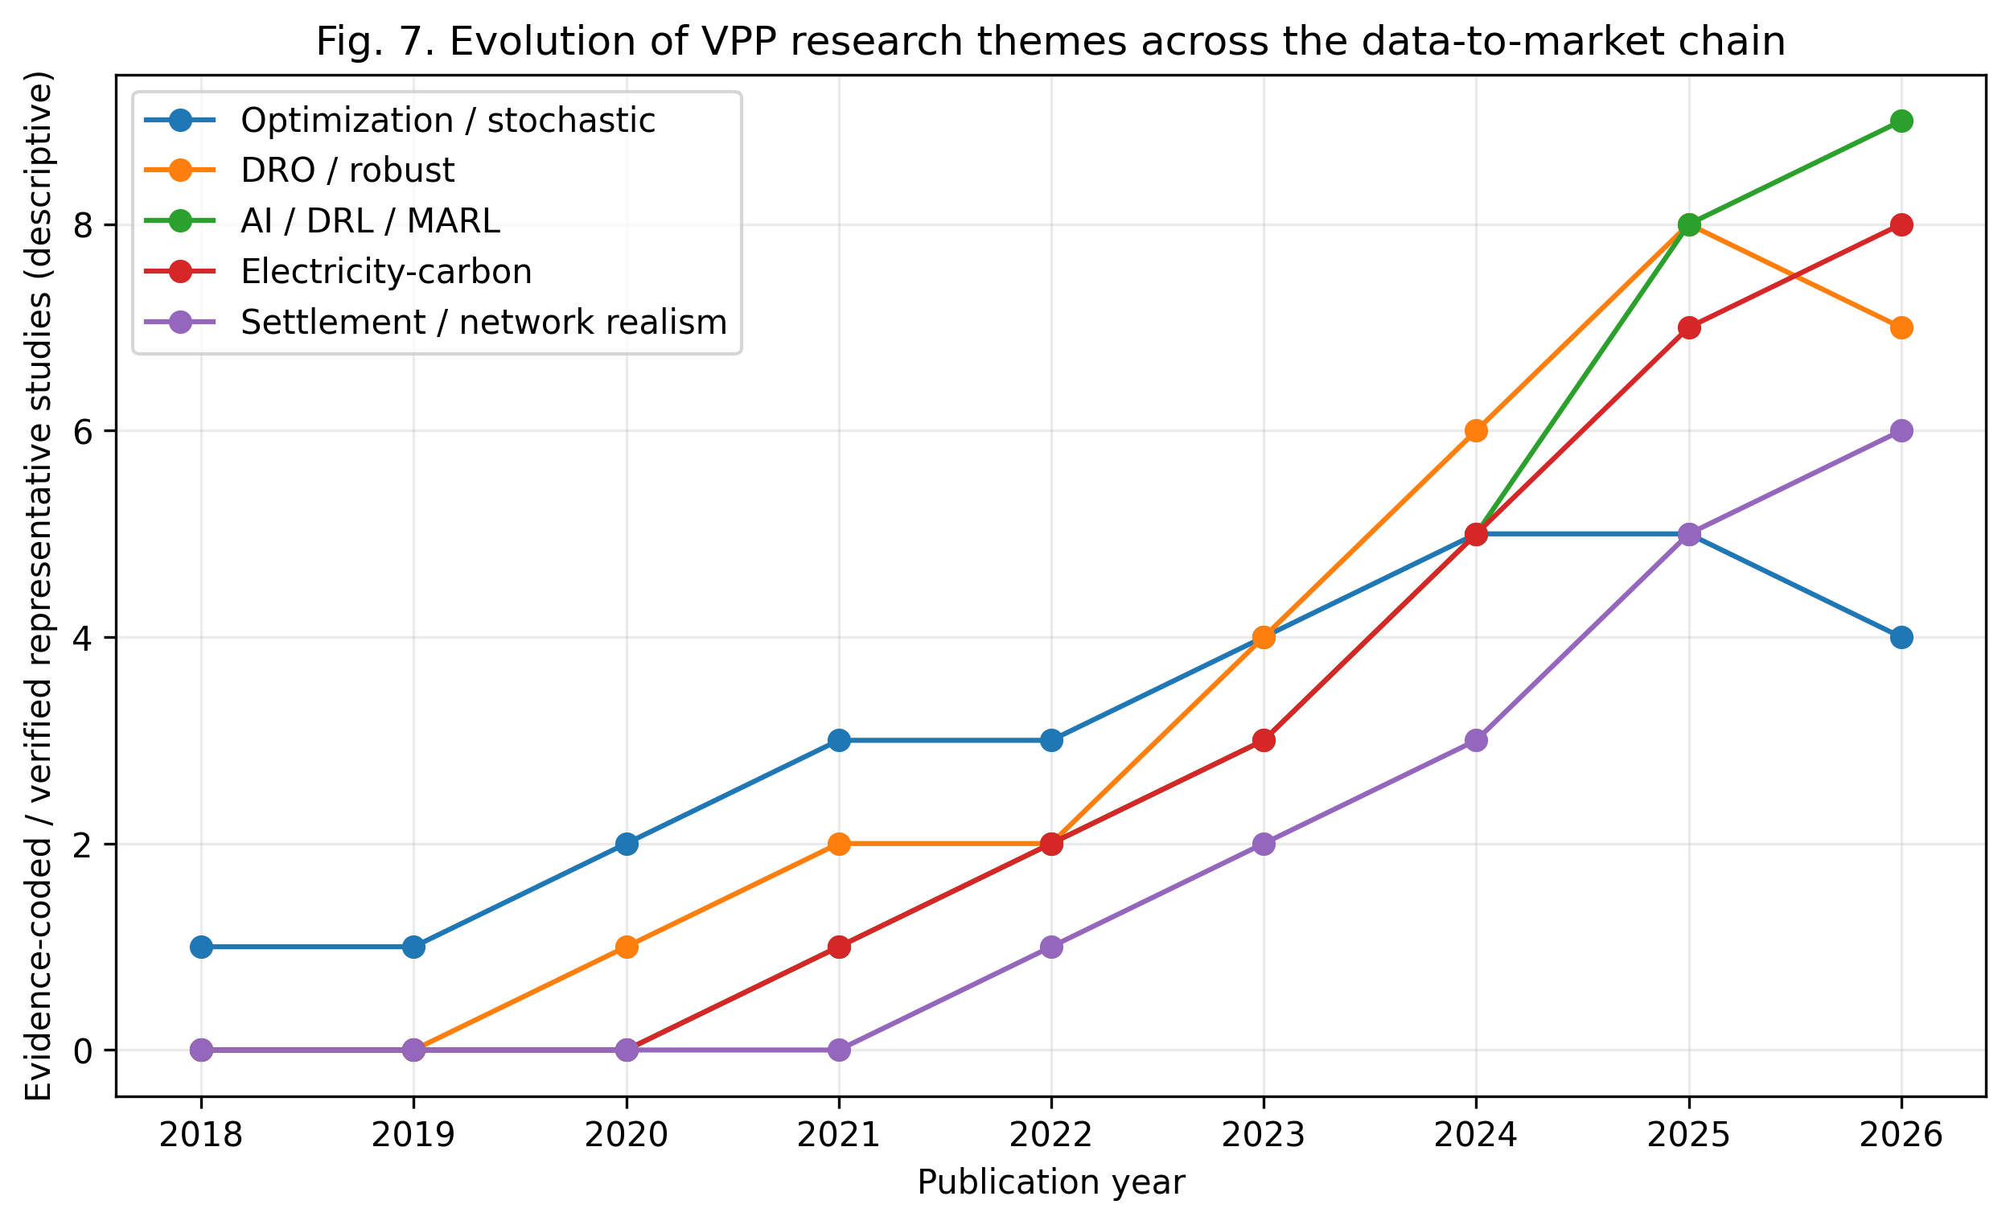
Fig. 8. Evolution of VPP research themes across the data-to-market chain. The plot is descriptive and is not a prevalence estimate for the full literature.
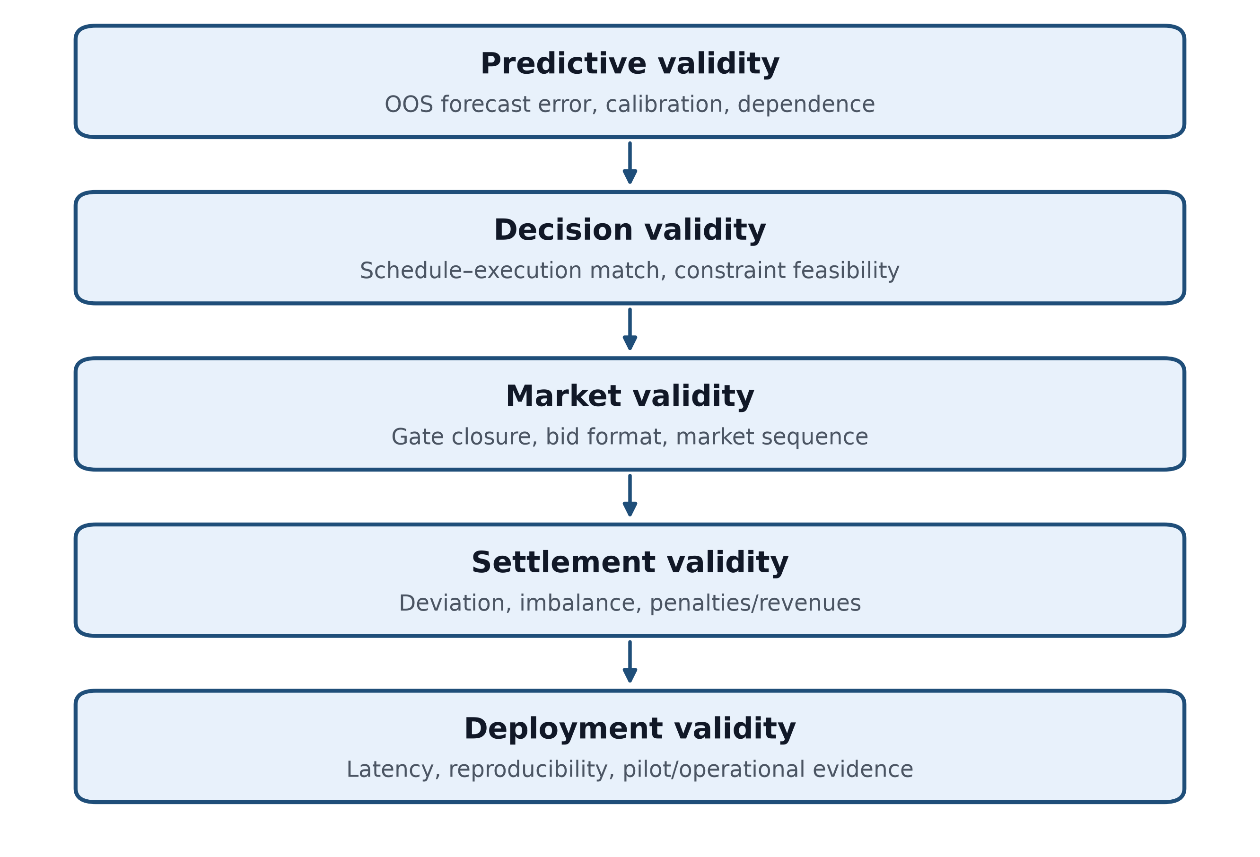
Fig. 9. DMDI validation stack. Forecast and algorithmic performance are progressively tested against decision, market, settlement, and deployment constraints.

11.1 Evidence bottlenecks in the data-to-market chain
Reading Tables XI–XIII together produces a consistent picture: information (I), decision (D), and market (M) integrity are comparatively strong; out-of-sample validity (O), settlement realism (S), and reproducibility (R) are comparatively weak, with uncertainty integrity (U) in between. This is not an artifact of any single evidence table — it recurs in the uncertainty/decision comparison (Table VIII), the market/settlement/carbon comparison (Tables IX–X), and the AI/forecasting comparison (Table XII) independently. The joint-structure analysis in Section 10.4 sharpens the claim: O and S are not merely rare, they are unassociated with the I/D/M cluster, and no study in the core is explicit on both. This pattern also mirrors the L1–L4 maturity ratings of the complementary Decision Integrity framework (Section 6.2): DMDI’s O/S/R weaknesses correspond closely to the Execution- and Governance-layer gaps identified there. We treat closing the O/S/R gap, rather than further algorithmic refinement of I/D/M, as the most consequential direction for the field (Section 11.2–11.6).

11.2 Information-set integrity as a reporting requirement
Future studies should explicitly define the information available at every decision point — measurement timestamps, forecast publication times, market gate closure, asset availability, and prices observed before bidding — ideally via a decision-time information table or equivalent machine-readable description. This directly addresses look-ahead bias and makes temporal causality auditable by a third party.

11.3 From uncertainty representation to uncertainty validation
Stochastic, robust, DRO, and risk-averse formulations should be evaluated as much by their empirical uncertainty-model quality — calibration, coverage, dependence preservation, temporal correlation, tail behavior, scenario-reduction distortion, and out-of-sample risk — as by their mathematical treatment of uncertainty.coverage, dependence preservation, temporal correlation, tail behavior, scenario-reduction distortion, and out-of-sample risk.

11.4 From AI accuracy to decision and market value
AI studies should report a hierarchy of evidence — predictive metrics, operational metrics, bidding metrics, realized market metrics — and prefer temporal hold-out tests to random splits for time-dependent market data. Regime-shift tests and ablations are especially valuable when AI is embedded in optimization or bidding.

11.5 Settlement realism and an expanded benchmark metric set
VPP market studies should represent the actual sequence of market decisions relevant to the modeled jurisdiction, and where imbalance settlement is material, should report scheduled energy, delivered energy, deviations, penalties, and settlement prices as distinct quantities (Section 8.3). We propose the following reporting set (Table XV):

TABLE XV — Decision-integrity metrics proposed for future benchmarking
Metric | Layer | Definition | DMDI linkage
Out-of-sample forecast error (MAE/RMSE) | Forecasting | Error on chronologically unseen data | O
Calibration error / PICP | Forecasting (probabilistic) | Deviation between nominal and empirical prediction-interval coverage | U
Interval width | Forecasting (probabilistic) | Mean width of predictive intervals at a stated coverage level | U
CRPS | Forecasting (probabilistic) | Continuous ranked probability score against realized outcomes | U
Scenario correlation error | Uncertainty | Discrepancy between scenario-set dependence and empirical dependence | U
Tail dependence error | Uncertainty | Discrepancy between scenario-set tail co-movement and empirical tail behavior | U
Profit volatility | Economic risk | σ(profit) across OOS periods/scenarios | MV/Risk
CVaR95 | Tail risk | Expected loss conditional on the worst 5% of outcomes | U/D
Schedule–execution match | Decision integrity | |E_actual − E_scheduled| / E_scheduled × 100 | D
Bid acceptance rate | Market realism | Share of submitted bids/offers cleared | M
Imbalance volume | Settlement | Total scheduled-vs-delivered deviation volume | S
Relative deviation cost | Settlement | Deviation penalty ÷ total realized profit × 100 | S
Real-time settlement cost | Settlement | Adjustment cost + imbalance/penalty payments | S
Uplift/settlement discrepancy | Settlement | Difference between objective-value profit and settled profit | S
Constraint violation rate | Decision/market integrity | Count or rate of physical/market constraint violations | D/M
Decision latency | Deployment | T_execution − T_decision | P/D
Computational time | Deployment | Wall-clock solve time per decision instance | P
Memory / inference latency | Deployment | Peak memory and per-inference latency for learned policies | P
These metrics are reporting variables, not a composite score, and should be reported separately because they measure distinct failure modes.

11.6 Reproducibility and coding-reliability roadmap
Beyond study-level reproducibility (open data, code, and parameterization — Section 5.1), we identify the review’s own coding reproducibility as an explicit, near-term task: (i) repeat the executed retrieval in Scopus, Web of Science, and IEEE Xplore and screen the combined frame exhaustively, so that the purposive selection in Section 2.4 can be replaced by a full exclusion cascade; (ii) recruit a second, blinded coder to re-apply the DMDI and Q1–Q8 instruments to the verified core and report agreement (e.g., Cohen’s κ or Krippendorff’s α) per dimension; (iii) retrospectively re-tag existing NR entries as NR-R or NR-U (Section 5.3); (iv) only after (i)–(iii), consider whether any numerical DMDI summary beyond the per-dimension counts in Table XI is warranted. Until then, this review presents its own quantitative statements with the same caution it applies to the primary literature it reviews.

11.7 Electricity–carbon coupling beyond objective-function aggregation
Carbon integration should be reported at the six accounting levels in Section 9.1 and positioned against the six coupling archetypes in Section 6.4, not merely as present/absent. Level 5–6 evidence (carbon-market clearing and settlement-coupled decisions) and Archetype A4–A6 mechanisms provide the strongest support for claims about coupled electricity–carbon value, because market timing, constraints, prices, and settlement interact directly with electricity-market decisions.

11.8 Answers to the research questions
RQ1 asked how VPP energy-management systems are structured across the chain, and the verified core answers it unevenly. Studies are strongest in the middle, where forecasting meets optimization and a bid is formed, and thin at both ends: few describe how measurements reach the model, and fewer still describe what happens after clearing. No coded study reports all ten links as one auditable sequence.
RQ2 asked how uncertainty, dependence, and tail behavior travel from forecasting into the decision. Representation travels well; calibration does not. Twenty-three of 39 studies state an uncertainty model explicitly, but dependence and tail behavior are usually asserted rather than reproduced from data, and the distortion introduced by scenario reduction is almost never quantified.
RQ3 asked whether forecast or AI performance translates into operational and market outcomes. For the most part it is not shown to. Predictive evidence and market-value evidence remain two largely separate literatures: studies report error metrics and stop, or report profit and never connect it to a change in the forecast.
RQ4 asked how carefully studies preserve information-set integrity, temporal causality, market timing, and out-of-sample validity. This is where the spread is widest. Information-set definitions are the best-reported dimension (22/39 explicit) and chronological out-of-sample evaluation the worst (2/39), so most reported performance rests on splits that a market would not have offered.
RQ5 asked how electricity and carbon decisions are coupled, and how uncertainty propagates between them. Coupling is real but shallow. Most studies reach objective, constraint, or market-participation coupling, few model a traded carbon position whose price is itself uncertain, and where coupling runs deep it is usually sequential rather than joint.
RQ6 asked about maturity. The verified core sits at Levels 1–4 of the ladder. Settlement-aware evidence is rare, pilot evidence rarer, and operational evidence absent, which is what most limits any claim about deployable value.

12. Limitations
Several limitations qualify every claim in this review. First, identification is executed but screening is not (Section 2.4). Table I reports what each query returned on 30 October 2026, and the de-duplicated frame of 1,668 works is a number any reader can reproduce; what we cannot offer is a record-by-record exclusion trail through that frame, because selection was purposive. The measured cost is a retrieval sensitivity of 35 of 39 for the coded core: two of the four misses are reviews whose abstracts carry none of the stream terms, and two are studies that never use the VPP label. Those are the numbers a reader should use to discount every claim in Sections 7–10, and they are the reason the paper is framed as a structured, PRISMA-informed review rather than a completed systematic review.
Second, structured coding has not yet been independently double-coded; the DMDI and maturity-ladder counts reported in Sections 7–10 should be read as indicative of a pattern rather than as externally validated prevalence statistics, and closing this gap is item (ii) of the research agenda (Section 11.6). Third, the NR-R/NR-U distinction introduced in Section 5.3 has been applied only prospectively; the existing 39-study matrix (Table XI) reports a combined NR column pending a re-tagging pass.
Fourth, the complementary Decision Integrity framework introduced in Section 6 is a conceptual, literature-wide threat-and-maturity taxonomy, not a per-study coded instrument like DMDI; its layer-maturity ratings (Table IV) are illustrative judgments by the authors rather than counts derived from the verified core, and should not be read as having the same evidentiary status as the DMDI tables in Sections 7–10. Fifth, heterogeneity in VPP definitions, market structures, datasets, horizons, and evaluation objectives limits direct meta-analysis for many technical metrics; the review therefore emphasizes structured evidence synthesis over pooled effect sizes.
Sixth, coverage — while spanning architecture, uncertainty, AI, market, and carbon streams — is not exhaustive for a 2018–2026 window; in particular, European market-design variants, probabilistic scenario-generation methodology, and hardware-in-the-loop validation studies are comparatively under-represented in the current verified core and are natural targets for the completed database screening.
Seventh, DMDI, the Decision Integrity framework, and the maturity ladder are proposed by this review and are not established external standards; their purpose is to provide an auditable structure for comparing evidence quality across heterogeneous VPP studies, not to rank individual papers or algorithms (Section 12.1). Eighth, the reference list was verified against Crossref and publisher DOI records, and every entry resolves to a real, independently locatable publication; verification of metadata is nevertheless a point-in-time check, since volume, issue, and page details for very recent articles can change between online-first and issue publication.

12.1 Boundary conditions for interpretation
The DMDI dimensions are designed to expose missing evidence and support transparent comparison across heterogeneous studies; they do not imply that every VPP application requires the same market products, settlement mechanism, or validation depth. Regulatory scope differs widely across jurisdictions [12], so a coding profile that looks adequate in one market can be silent on obligations that another market imposes. The maturity ladder describes the strength of empirical validation and deployment evidence, not the scientific quality of an algorithm in isolation — a synthetic-simulation study using a genuinely novel formulation and a settlement-aware pilot study using a comparatively simple heuristic occupy different rungs of the ladder for reasons that have nothing to do with which is the better piece of applied mathematics.

13. Conclusion
VPP research is increasingly data-driven, uncertainty-aware, AI-enabled, and market-oriented. The consequential question is whether an improvement survives the complete data-to-market chain. This review shifts the unit of analysis from the isolated algorithm to decision integrity: what information was available, how uncertainty was represented, how the decision was produced, how the bid interacted with the market, how deviations were settled, and what economic or carbon value was realized.
Within the limits stated in Section 12 — chief among them, that screening of the retrieved frame was purposive rather than exhaustive and that structured coding has not yet been independently double-coded — the verified-core evidence supports a consistent pattern: information-set, decision, and market integrity are comparatively well reported in the 2018–2026 VPP literature, while out-of-sample validity, settlement realism, and reproducibility are comparatively weak. Electricity–carbon market coupling is an active but still comparatively under-reviewed methodological frontier, with primary research on joint bidding and carbon-price-linked strategy accelerating faster than dedicated review-level synthesis of its accounting and dynamic-pricing methodology. The proposed DMDI framework and Data-to-Market Maturity Ladder are offered as diagnostic, auditable tools — not validated external standards — toward a VPP research agenda that treats settlement-aware benchmarking, chronological out-of-sample evaluation, explicit carbon-accounting-boundary reporting, and coding-level reproducibility as first-class evidence, alongside continued algorithmic innovation.

Data Availability Statement
The per-study coding matrix for the 39 verified-core studies is provided as supplementary file DMDI_Coding_Matrix.csv, together with the DMDI codebook (the explicit coding rules used for each dimension and level) and the analysis script that regenerates every count in Table XI from the matrix. It reproduces the 39 × 8 grid of Fig. 5 — the seven DMDI dimensions plus the deployment-maturity companion field — and is the source of every count in Table XI. A blank second-coder version of the same sheet, and the script that computes per-dimension agreement, accompany it, so that the double-coding step described in Section 2.7 can be run against the same rules. The retrieval log in Table I and the search strings in Section 2.3 are sufficient to re-execute the identification stage. No new empirical measurements were generated for this review.

Declaration of Competing Interest
The authors declare that they have no known competing financial interests or personal relationships that could have appeared to influence the work reported in this paper.

Use of AI-Assisted Technologies
A large language model was used to support literature triage, first-pass evidence coding, and language editing, under direct author supervision. The scope and limits of that use are stated in Section 2.7. The authors reviewed every coded entry, every interpretive claim, and the final reference list, and take full responsibility for the content of the article.

Author Contributions
[To be completed before submission: author initials, contribution, and CRediT role.]

14. References
[1] G. Zhang, C. Jiang, and X. Wang, “Comprehensive review on structure and operation of virtual power plant in electrical system,” IET Generation, Transmission & Distribution, vol. 13, no. 2, pp. 145–156, 2019, doi: 10.1049/iet-gtd.2018.5880.
[2] L. Yavuz, A. Önen, S. M. Muyeen, and I. Kamwa, “Transformation of microgrid to virtual power plant — A comprehensive review,” IET Generation, Transmission & Distribution, vol. 13, no. 11, pp. 1994–2005, 2019, doi: 10.1049/iet-gtd.2018.5649.
[3] M. Rahimiyan and L. Baringo, “Real-time energy management of a smart virtual power plant,” IET Generation, Transmission & Distribution, vol. 13, no. 11, pp. 2015–2023, 2019, doi: 10.1049/iet-gtd.2018.5637.
[4] G. Ruan, D. Qiu, S. Sivaranjani, A. S. A. Awad, and G. Strbac, “Data-driven energy management of virtual power plants: A review,” Advances in Applied Energy, vol. 14, Art. no. 100170, 2024, doi: 10.1016/j.adapen.2024.100170.
[5] H. Gao, T. Jin, C. Feng, C. Li, Q. Chen, and C. Kang, “Review of virtual power plant operations: Resource coordination and multidimensional interaction,” Applied Energy, vol. 357, Art. no. 122284, 2024, doi: 10.1016/j.apenergy.2023.122284.
[6] M. Kaiss, Y. Wan, D. Gebbran, C. U. Vila, and T. Dragičević, “Review on Virtual Power Plants/Virtual Aggregators: Concepts, applications, prospects and operation strategies,” Renewable and Sustainable Energy Reviews, vol. 211, Art. no. 115242, 2025, doi: 10.1016/j.rser.2024.115242.
[7] M. Esfahani, A. Alizadeh, B. Cao, I. Kamwa, and M. Xu, “Bridging theory and practice: A comprehensive review of virtual power plant technologies and their real-world applications,” Renewable and Sustainable Energy Reviews, vol. 222, Art. no. 115929, 2025, doi: 10.1016/j.rser.2025.115929.
[8] A. Zare, M. Shafie-khah, P. Siano, and G. C. Lazaroiu, “A systematic review of Virtual Power Plant configurations and their interaction with electricity, carbon, and flexibility markets,” Renewable and Sustainable Energy Reviews, vol. 226, Art. no. 116448, 2026, doi: 10.1016/j.rser.2025.116448.
[9] M. J. Page et al., “The PRISMA 2020 statement: An updated guideline for reporting systematic reviews,” BMJ, vol. 372, Art. no. n71, 2021, doi: 10.1136/bmj.n71.
[10] E. J. Choi, G.-S. Seo, and S. W. Kim, “Are better combinations of DERs more profitable? Combinatorial optimization for aggregation of DERs in wholesale electricity markets,” Applied Energy, vol. 396, Art. no. 126264, 2025, doi: 10.1016/j.apenergy.2025.126264.
[11] S. Zhang, W. Deng, Y. Zhang, Z. Jing, N. Guo, J. Yu, B. Wang, and M. Liao, “A multi-agent closed-loop decision-making framework for joint forecasting and bidding in electricity spot markets,” Energies, vol. 18, no. 24, Art. no. 6486, 2025, doi: 10.3390/en18246486.
[12] H. Bhattarai, A. Aziz, and S. W. Lachowicz, “Policy and regulation in virtual power plants development,” Utilities Policy, vol. 101, Art. no. 102212, 2026, doi: 10.1016/j.jup.2026.102212.
[13] A. Bedi, J. Ramprabhakar, R. Anand, V. P. Meena, and I. A. Hameed, “Empowering net zero energy grids: A comprehensive review of virtual power plants, challenges, applications, and blockchain integration,” Discover Applied Sciences, vol. 7, no. 4, Art. no. 252, 2025, doi: 10.1007/s42452-025-06691-1.
[14] P. Bendigiri and P. Rao, “A critical review of virtual power plants for distributed renewable energy projects in the built environment,” Discover Sustainability, vol. 7, no. 1, Art. no. 798, 2026, doi: 10.1007/s43621-026-03202-z.
[15] Q. Fan and D. Liu, “A Wasserstein-distance-based distributionally robust chance-constrained bidding model for virtual power plant considering electricity-carbon trading,” IET Renewable Power Generation, vol. 18, no. 3, pp. 545–557, 2024, doi: 10.1049/rpg2.12806.
[16] G. Wang, Z. Lin, Y. Chen, R. Qiu, H. Zhang, and J. Yan, “Carbon-billed future for virtual power plants: A comprehensive review,” Renewable and Sustainable Energy Reviews, vol. 217, Art. no. 115719, 2025, doi: 10.1016/j.rser.2025.115719.
[17] D. Wozabal and G. Rameseder, “Optimal bidding of a virtual power plant on the Spanish day-ahead and intraday market for electricity,” European Journal of Operational Research, vol. 280, no. 2, pp. 639–655, 2020, doi: 10.1016/j.ejor.2019.07.022.
[18] M. Vahedipour-Dahraie, H. Rashidizadeh-Kermani, A. Anvari-Moghaddam, and P. Siano, “Risk-averse probabilistic framework for scheduling of virtual power plants considering demand response and uncertainties,” International Journal of Electrical Power & Energy Systems, vol. 121, Art. no. 106126, 2020, doi: 10.1016/j.ijepes.2020.106126.
[19] S. Sadeghi, H. Jahangir, B. Vatandoust, M. A. Golkar, A. Ahmadian, and A. Elkamel, “Optimal bidding strategy of a virtual power plant in day-ahead energy and frequency regulation markets: A deep learning-based approach,” International Journal of Electrical Power & Energy Systems, vol. 127, Art. no. 106646, 2021, doi: 10.1016/j.ijepes.2020.106646.
[20] S. Sadeghi Gougheri et al., “Optimal participation of a virtual power plant in electricity market considering renewable energy: A deep learning-based approach,” Sustainable Energy, Grids and Networks, vol. 26, Art. no. 100448, 2021, doi: 10.1016/j.segan.2021.100448.
[21] Y. Wang, W. Fu, J. Wang, Z. Zhen, and F. Wang, “Ultra-short-term distributed PV power forecasting for virtual power plant considering data-scarce scenarios,” Applied Energy, vol. 373, Art. no. 123890, 2024, doi: 10.1016/j.apenergy.2024.123890.
[22] R. Nadimi and M. Goto, “Uncertainty reduction in power forecasting of virtual power plant: From day-ahead to balancing markets,” Renewable Energy, vol. 238, Art. no. 121875, 2025, doi: 10.1016/j.renene.2024.121875.
[23] R. Nadimi and M. Goto, “A novel decision support system for enhancing long-term forecast accuracy in virtual power plants using bidirectional long short-term memory networks,” Applied Energy, vol. 382, Art. no. 125273, 2025, doi: 10.1016/j.apenergy.2025.125273.
[24] W. Li, “The virtual power plant bidding strategy model based on multi-stage semi-anticipativity distributionally robust optimization,” Electric Power Systems Research, vol. 237, Art. no. 111015, 2024, doi: 10.1016/j.epsr.2024.111015.
[25] W. Li, F. Dong, Z. Ji, and P. Wang, “Internal and external coordinated distributionally robust bidding strategy of virtual power plant operator participating in day-ahead electricity spot and peaking ancillary services markets,” Applied Energy, vol. 386, Art. no. 125514, 2025, doi: 10.1016/j.apenergy.2025.125514.
[26] C. Song, Y. Yuan, and L. Dai, “Distributionally robust optimization of virtual power plant bidding strategies considering discrete scenario-based uncertainties in day-ahead market prices and wind powers,” Electric Power Systems Research, vol. 248, Art. no. 111977, 2025, doi: 10.1016/j.epsr.2025.111977.
[27] Y. Ma, Z. Li, R. Liu, B. Liu, S. S. Yu, X. Liao, and P. Shi, “Data-driven interval robust optimization method of VPP bidding strategy in spot market under multiple uncertainties,” Applied Energy, vol. 384, Art. no. 125366, 2025, doi: 10.1016/j.apenergy.2025.125366.
[28] J. Wang, C. Guo, C. Yu, and Y. Liang, “Virtual power plant containing electric vehicles scheduling strategies based on deep reinforcement learning,” Electric Power Systems Research, vol. 205, Art. no. 107714, 2022, doi: 10.1016/j.epsr.2021.107714.
[29] B. Xu, W. Luan, J. Yang, B. Zhao, C. Long, Q. Ai, and J. Xiang, “Integrated three-stage decentralized scheduling for virtual power plants: A model-assisted multi-agent reinforcement learning method,” Applied Energy, vol. 376, Art. no. 123985, 2024, doi: 10.1016/j.apenergy.2024.123985.
[30] H.-C. Wu, D. Qiu, L. Zhang, and M. Sun, “Adaptive multi-agent reinforcement learning for flexible resource management in a virtual power plant with dynamic participating multi-energy buildings,” Applied Energy, vol. 374, Art. no. 123998, 2024, doi: 10.1016/j.apenergy.2024.123998.
[31] X. Liu, “Research on bidding strategy of virtual power plant considering carbon-electricity integrated market mechanism,” International Journal of Electrical Power & Energy Systems, vol. 137, Art. no. 107891, 2022, doi: 10.1016/j.ijepes.2021.107891.
[32] R. Liu, K. Chen, G. Sun, S. Lin, and C. Jiang, “Bidding strategy for the virtual power plant based on cooperative game participating in the Electricity-Carbon joint market,” International Journal of Electrical Power & Energy Systems, vol. 163, Art. no. 110325, 2024, doi: 10.1016/j.ijepes.2024.110325.
[33] Y. Wang, J. Xu, W. Pei, H. Wang, and Z. Zhang, “Low-carbon economic scheduling of virtual power plant considering carbon emission flow and demand response,” Frontiers in Energy Research, vol. 12, Art. no. 1398655, 2024, doi: 10.3389/fenrg.2024.1398655.
[34] J. Bian, J. Cheng, H. Wang, G. Li, and S. Li, “CVaR-based bi-level bidding strategy for VPP to participate in energy-regulation-carbon markets,” International Journal of Electrical Power & Energy Systems, vol. 174, Art. no. 111555, 2026, doi: 10.1016/j.ijepes.2025.111555.
[35] Y. Song, Y. Chu, Y. Yoon, and Y. Jin, “Virtual power plant bidding strategies in pay-as-bid and pay-as-clear markets: Analysis of imbalance penalties and market operations,” Energies, vol. 18, no. 6, Art. no. 1383, 2025, doi: 10.3390/en18061383.
[36] N. Naval and J. M. Yusta, “Virtual power plant models and electricity markets — A review,” Renewable and Sustainable Energy Reviews, vol. 149, Art. no. 111393, 2021, doi: 10.1016/j.rser.2021.111393.
[37] P. Mo, K. Li, Y. Lu, Y. Wen, and K. Huang, “Deep reinforcement learning-based bidding strategies for virtual power plants in electricity spot markets: A review,” IEEE Access, vol. 14, pp. 50628–50643, 2026, doi: 10.1109/ACCESS.2026.3678911.
[38] H. Zhu, Z. Zhang, Y. Gao, X. Hu, Y. Cai, Y. Wang, Q. Wang, and Q. Ai, “Application of deep learning in virtual power plants — A review,” Energy Internet, vol. 3, no. 2, pp. 97–110, 2026, doi: 10.1049/ein2.70027.
[39] J. Li, C. Wang, and Y. Liu, “AI-driven virtual power plants: A comprehensive review,” Energies, vol. 19, no. 4, Art. no. 1084, 2026, doi: 10.3390/en19041084.
[40] K. N. Singh, A. K. Goswami, N. B. D. Choudhury, T. S. Ustun, and U. Cali, “Virtual power plants in modern power systems: A comprehensive review of uncertainty management and market bidding strategies,” IEEE Access, vol. 14, pp. 75331–75355, 2026, doi: 10.1109/ACCESS.2026.3691418.
[41] Y. Liu, P. Ning, and M. K. Reiter, “False data injection attacks against state estimation in electric power grids,” ACM Transactions on Information and System Security, vol. 14, no. 1, Art. no. 13, 2011, doi: 10.1145/1952982.1952995.
[42] G. Liang, J. Zhao, F. Luo, S. R. Weller, and Z. Y. Dong, “A review of false data injection attacks against modern power systems,” IEEE Transactions on Smart Grid, vol. 8, no. 4, pp. 1630–1638, 2017, doi: 10.1109/TSG.2015.2495133.
[43] I. J. Goodfellow, J. Shlens, and C. Szegedy, “Explaining and harnessing adversarial examples,” in Proc. Int. Conf. Learning Representations (ICLR), San Diego, CA, USA, 2015.
[44] P. Mohajerin Esfahani and D. Kuhn, “Data-driven distributionally robust optimization using the Wasserstein metric: Performance guarantees and tractable reformulations,” Mathematical Programming, vol. 171, nos. 1–2, pp. 115–166, 2018, doi: 10.1007/s10107-017-1172-1.
[45] S. M. Lundberg and S.-I. Lee, “A unified approach to interpreting model predictions,” in Proc. Advances in Neural Information Processing Systems (NeurIPS), Long Beach, CA, USA, 2017, pp. 4765–4774.
[46] M. T. Ribeiro, S. Singh, and C. Guestrin, “‘Why should I trust you?’: Explaining the predictions of any classifier,” in Proc. ACM SIGKDD Int. Conf. Knowledge Discovery and Data Mining, San Francisco, CA, USA, 2016, pp. 1135–1144, doi: 10.1145/2939672.2939778.
[47] F. Tao, H. Zhang, A. Liu, and A. Y. C. Nee, “Digital twin in industry: State-of-the-art,” IEEE Transactions on Industrial Informatics, vol. 15, no. 4, pp. 2405–2415, 2019, doi: 10.1109/TII.2018.2873186.
[48] M. Andoni et al., “Blockchain technology in the energy sector: A systematic review of challenges and opportunities,” Renewable and Sustainable Energy Reviews, vol. 100, pp. 143–174, 2019, doi: 10.1016/j.rser.2018.10.014.
[49] H. B. McMahan, E. Moore, D. Ramage, S. Hampson, and B. A. y Arcas, “Communication-efficient learning of deep networks from decentralized data,” in Proc. Int. Conf. Artificial Intelligence and Statistics (AISTATS), Fort Lauderdale, FL, USA, 2017, pp. 1273–1282.
[50] Q. Zhang, F. Li, Q. Shi, K. Tomsovic, J. Sun, and L. Ren, “Profit-oriented false data injection on electricity market: Reviews, analyses, and insights,” IEEE Transactions on Industrial Informatics, vol. 17, no. 9, pp. 5876–5886, 2021, doi: 10.1109/TII.2020.3036104.
[51] L. Xie, G. Li, M. Xu, X. Dong, and Z. Tan, “Optimizing virtual power plant coordination through locational marginal flexibility under network constraints,” Scientific Reports, vol. 16, no. 1, Art. no. 3789, 2026, doi: 10.1038/s41598-025-33726-9.
[52] S. Wang and W. Wu, “Aggregate flexibility of virtual power plants with temporal coupling constraints,” IEEE Trans. Smart Grid, vol. 12, no. 6, pp. 5043–5051, 2021, doi: 10.1109/TSG.2021.3106646.
[53] S. Boyd, N. Parikh, E. Chu, B. Peleato, and J. Eckstein, “Distributed optimization and statistical learning via the alternating direction method of multipliers,” Foundations and Trends in Machine Learning, vol. 3, no. 1, pp. 1–122, 2011, doi: 10.1561/2200000016.
[54] J. F. Benders, “Partitioning procedures for solving mixed-variables programming problems,” Numerische Mathematik, vol. 4, no. 1, pp. 238–252, 1962, doi: 10.1007/BF01386316.
[55] J. F. Nash, “Non-cooperative games,” Annals of Mathematics, vol. 54, no. 2, pp. 286–295, 1951, doi: 10.2307/1969529.
[56] L. S. Shapley, “A value for n-person games,” in Contributions to the Theory of Games, vol. 2, H. W. Kuhn and A. W. Tucker, Eds. Princeton, NJ, USA: Princeton Univ. Press, 1953, pp. 307–317.
[57] R. T. Rockafellar and S. Uryasev, “Optimization of conditional value-at-risk,” Journal of Risk, vol. 2, no. 3, pp. 21–41, 2000, doi: 10.21314/JOR.2000.038.
[58] Y. Ben-Haim, Info-Gap Decision Theory: Decisions Under Severe Uncertainty, 2nd ed. Oxford, U.K.: Academic Press, 2006.
[59] J. R. Birge and F. Louveaux, Introduction to Stochastic Programming, 2nd ed. New York, NY, USA: Springer, 2011, doi: 10.1007/978-1-4614-0237-4.
[60] A. Charnes and W. W. Cooper, “Chance-constrained programming,” Management Science, vol. 6, no. 1, pp. 73–79, 1959, doi: 10.1287/mnsc.6.1.73.
[61] D. Bertsimas and M. Sim, “The price of robustness,” Operations Research, vol. 52, no. 1, pp. 35–53, 2004, doi: 10.1287/opre.1030.0065.
[62] A. Ben-Tal, L. El Ghaoui, and A. Nemirovski, Robust Optimization. Princeton, NJ, USA: Princeton Univ. Press, 2009.
[63] Z. Siqin, R. Diao, and M. Zhao, “Two-stage distributionally robust bidding strategies for multi-energy virtual power plants in energy, reserve and carbon markets,” Energy, vol. 334, Art. no. 137455, 2025, doi: 10.1016/j.energy.2025.137455.
[64] Y. Wang, J. Xu, W. Pei, H. Wang, and Z. Zhang, “A risk-aware bidding model for virtual power plants: Integrating renewable energy forecasting and carbon market strategies,” Energy Reports, vol. 14, pp. 1222–1239, 2025, doi: 10.1016/j.egyr.2025.07.032.
[65] Y. Li, W. Chang, and Q. Yang, “Deep reinforcement learning based hierarchical energy management for virtual power plant with aggregated multiple heterogeneous microgrids,” Applied Energy, vol. 382, Art. no. 125333, 2025, doi: 10.1016/j.apenergy.2025.125333.
[66] Z. Luo, S. Hong, and Y. Ding, “A data mining-driven incentive-based demand response scheme for a virtual power plant,” Applied Energy, vol. 239, pp. 549–559, 2019, doi: 10.1016/j.apenergy.2019.01.142.
[67] D. Falabretti, F. Gulotta, and D. Siface, “Scheduling and operation of RES-based virtual power plants with e-mobility: A novel integrated stochastic model,” International Journal of Electrical Power & Energy Systems, vol. 144, Art. no. 108604, 2023, doi: 10.1016/j.ijepes.2022.108604.
[68] X. Kong, J. Xiao, D. Liu, J. Wu, C. Wang, and Y. Shen, “Robust stochastic optimal dispatching method of multi-energy virtual power plant considering multiple uncertainties,” Applied Energy, vol. 279, Art. no. 115707, 2020, doi: 10.1016/j.apenergy.2020.115707.
[69] Y. Chen, Y. Niu, M. Du, and J. Wang, “A two-stage robust optimization model for a virtual power plant considering responsiveness-based electric vehicle aggregation,” Journal of Cleaner Production, vol. 405, Art. no. 136690, 2023, doi: 10.1016/j.jclepro.2023.136690.
[70] M. Shafiekhani, A. Badri, M. Shafie-khah, and J. P. S. Catalão, “Strategic bidding of virtual power plant in energy markets: A bi-level multi-objective approach,” International Journal of Electrical Power & Energy Systems, vol. 113, pp. 208–219, 2019, doi: 10.1016/j.ijepes.2019.05.023.
[71] J. Hu, C. Jiang, and Y. Liu, “Short-term bidding strategy for a price-maker virtual power plant based on interval optimization,” Energies, vol. 12, no. 19, Art. no. 3662, 2019, doi: 10.3390/en12193662.
[72] C. Yang, X. Du, D. Xu, J. Tang, X. Lin, K. Xie, and W. Li, “Optimal bidding strategy of renewable-based virtual power plant in the day-ahead market,” International Journal of Electrical Power & Energy Systems, vol. 144, Art. no. 108557, 2023, doi: 10.1016/j.ijepes.2022.108557.
[73] M. Esfahani, A. Alizadeh, N. Amjady, and I. Kamwa, “A distributed VPP-integrated co-optimization framework for energy scheduling, frequency regulation, and voltage support using data-driven distributionally robust optimization with Wasserstein metric,” Applied Energy, vol. 361, Art. no. 122883, 2024, doi: 10.1016/j.apenergy.2024.122883.
[74] H. Liu, J. Qiu, and J. Zhao, “A data-driven scheduling model of virtual power plant using Wasserstein distributionally robust optimization,” Int. J. Electr. Power Energy Syst., vol. 137, Art. no. 107801, 2022, doi: 10.1016/j.ijepes.2021.107801.
[75] S. Kim and H. Choi, “A sample robust optimal bidding model for a virtual power plant,” European Journal of Operational Research, vol. 316, no. 3, pp. 1101–1113, 2024, doi: 10.1016/j.ejor.2024.03.001.
[76] M. Mousavi, M. Rayati, and A. M. Ranjbar, “Optimal operation of a virtual power plant in frequency constrained electricity market,” IET Generation, Transmission & Distribution, vol. 13, no. 11, pp. 2123–2133, 2019, doi: 10.1049/iet-gtd.2018.5204.
[77] M. A. Niazi, V. Kumar, T. Chen, and M. Zhu, “Scalable co-optimization of virtual power plants in frequency regulation markets: Integrating stochastic bidding and mean field games,” Energy, vol. 358, Art. no. 141360, 2026, doi: 10.1016/j.energy.2026.141360.
[78] S. Mei, Q. Tan, A. Trivedi, and D. Srinivasan, “A two-step optimization model for virtual power plant participating in spot market based on energy storage power distribution considering comprehensive forecasting error of renewable energy output,” Applied Energy, vol. 376, Art. no. 124234, 2024, doi: 10.1016/j.apenergy.2024.124234.
[79] J. Jin, X. Pang, B. Wang, D. Wang, and Z. Zheng, “Optimal scheduling method of carbon-green certificate trading virtual power plant via Q-learning-enhanced particle swarm algorithm,” Complex & Intelligent Systems, vol. 12, no. 1, Art. no. 51, 2026, doi: 10.1007/s40747-025-02176-1.
[80] X. Chang, Z. Wu, J. Wang, X. Zhang, M. Zhou, T. Yu, and Y. Wang, “The coupling effect of carbon emission trading and tradable green certificates under electricity marketization in China,” Renewable and Sustainable Energy Reviews, vol. 187, Art. no. 113750, 2023, doi: 10.1016/j.rser.2023.113750.
[81] Y. Wang, C. Xu, D. Xie, C. Gu, P. Zhao, J. Gong, M. Pan, and X. Wang, “A novel scheduling strategy for virtual power plant based on power market dynamic triggers,” Applied Energy, vol. 350, Art. no. 121758, 2023, doi: 10.1016/j.apenergy.2023.121758.
[82] C. Böhringer, C. Fischer, K. E. Rosendahl, and T. F. Rutherford, “Potential impacts and challenges of border carbon adjustments,” Nature Climate Change, vol. 12, no. 1, pp. 22–29, 2022, doi: 10.1038/s41558-021-01250-z.

